**Order Decomposition**

https://help.salesforce.com/s/articleView?id=ind.comms_t_order_decomposition_conditions_230259.htm&type=5

Order Decomposition Conditions

Decomposition relationships may have associated conditions. A condition rule places a condition on the decomposition relationship. Order Management initiates decomposition of an order item only if the specified condition evaluates as true. Otherwise, Order Management skips the decomposition relationship.

Condition rules can evaluate attributes or fields on the order item, as well as other fields that are related to the order item as long as the entire order is included in the fulfillment request.

Decomposition Conditions

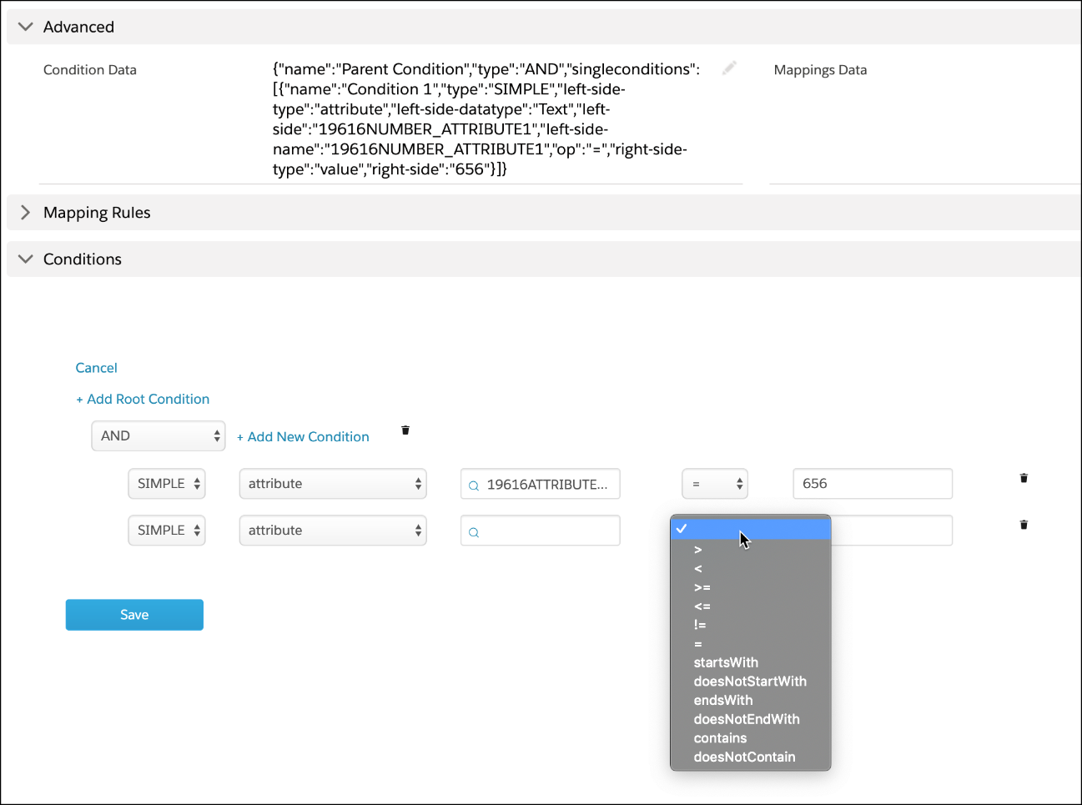

**Mapping Rules for Decomposition**

<https://help.salesforce.com/s/articleView?id=ind.comms_t_mapping_rules_for_order_decomposition_230302.htm&type=5>

Mapping Rules provide a way to pass the attributes of your commercial products and services, such as phone numbers, mobile features, line equipment, upload speed, and download speed, to technical products for later consumption by fulfillment systems.

After you have configured a decomposition relationship that associates a commercial product (an offer) with a technical product, you can define mapping rules that map fields or attributes in an offer to the technical product.

Mapping rules are invoked at order decomposition and used to create fulfillment requests. Mapping rules define the information passed from the source product to the destination product, and thereby to downstream systems. The source product data can be a field or an attribute, but the destination product data must be stored as an attribute.

To define mapping rules, you must specify:

Mapping type: ad-verbatim | List | Static

Mapping Source: Where are the values coming from? You can choose Source Product or Related Product. If you've configured a product to rely on another, then those pr

Source field: Name of the actual field or attribute of the source product

Destination attribute: Name of the attribute in the destination technical product.

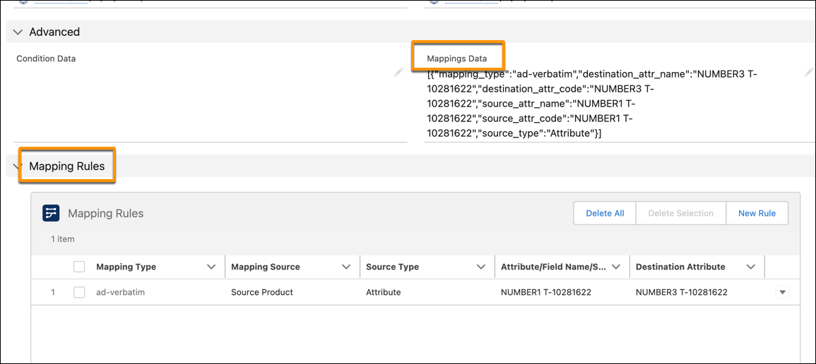

# Types of Mapping Rules

When configuring mapping rules for a decomposition relationship, you must select a mapping type that defines how data from a source product attribute or field maps to a corresponding destination product attribute.

Mapping rules only apply if a decomposition relationship is activated, for example, if a condition set for the decomposition relationship is evaluated as true.

Order Management supports the following mapping types:

* [Ad-Verbatim](https://help.salesforce.com/s/articleView?id=ind.comms_t_types_of_mapping_rules_230334.htm&language=en_US&type=5#t_types_of_mapping_rules_230334__t_ad_verbatim_mapping_type_230351)
* [List Mapping](https://help.salesforce.com/s/articleView?id=ind.comms_t_types_of_mapping_rules_230334.htm&language=en_US&type=5#t_types_of_mapping_rules_230334__t_list_mapping_type_230354)
* [Static Mapping](https://help.salesforce.com/s/articleView?id=ind.comms_t_types_of_mapping_rules_230334.htm&language=en_US&type=5#t_types_of_mapping_rules_230334__t_static_mapping_type_230379)

## Ad-Verbatim Mapping Type

In an Ad-Verbatim mapping, the value of the source attribute is copied as is to the destination attribute on the decomposed product. In other words, no transformation of the value is performed.

## List Mapping Type

List mapping is configured as pairs of source value and destination value. For a given list mapping, the source value is set to the corresponding destination value.

For example, a source commercial product has the attribute Speed with two values: Fast and Ultra Fast. The destination technical product has a Bandwidth attribute with two values: 2 Mbps and 10 Mbps. You create the following List mapping for the Speed and Bandwidth attributes as:

* **Source Value**: Fast, **Destination Value**: 2 Mbps
* **Source Value**: Ultra Fast, **Destination Value**: 10 Mbps

Based on the above mappings:

* If the source order has Fast as a value of the Speed attribute, the Bandwidth on the decomposed order is set to 2 Mbps.
* If the source order has Ultra Fast as a value of the Speed attribute, the Bandwidth of the decomposed order is set to 10 Mbps
* If the source order has Slow as a value of Speed attribute or any other value, no value will be set for the Bandwidth attribute, as the Slow attribute value has no mapping.

## Static Mapping Type

Static mapping enables you to explicitly specify any value to a selected destination attribute.

# Configure Mapping with a Relies On Relationship

If a commercial product relies on another, you can use the Related Product option to map attributes from that relied on product to a technical product.

Configure a Relies On relationship in the catalog, then configure mapping. Finally, in the order itself, configure the relevant order line items to have a Relies On relationship.

1. In the catalog, configure a commercial product to rely on another commercial product.
2. Set up attribute and field mapping for the product that relies on the other one, selecting **Related Products** from the **Mapping Source** dropdown menu.
3. In each relevant order, configure the commercial products to have an Order Product Relationship with each other, using the Relationship Type of **Relies On**.

# Multi-Level Decomposition Modeling

A multi-level decomposition is an order decomposition configuration where a sales order is recursively decomposed into lower tiers.

A sales order can be decomposed into a number of Customer-Facing Services orders and these Customer-Facing Service Orders are decomposed into Resource-Facing Service Orders. You can use multi-level decomposition to ensure re-use between order decomposition configurations. In particular, multiple products could re-use the same Customer-Facing Services decompositions, thus reducing the time to introduce a new product.

For example, TV Service can be sold independently or within a Triple Play offer. However, you want to use the same billing process in both situations. Most implementations would follow a phased approach and go to production with services as they are built. However, once all the product lines have been configured for fulfillment, it should be possible to create commercial bundles, such as triple-play and quad-play, without much impact on the fulfillment side because the processes used for individual services should also apply to a bundle. This use case is easily supported through decomposition. When creating a higher-level bundle, you can add a decomposition relationship to the grouping product and the decomposition results in only one fulfillment request for that product.

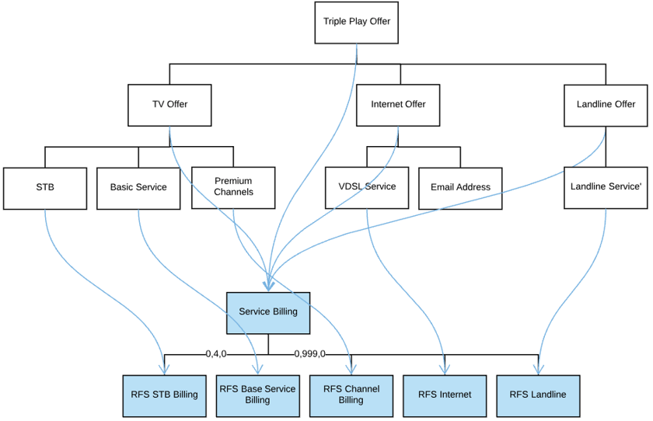

You can use Multi-stage decomposition to model the technical catalog in multiple levels according to TM F’orum's SID modeling. You can model the technical catalog with the CFS layer that decomposes to the RFS layer. The CFS layer models the service as perceived by the commercial layer, whereas the RFS layer models the service as perceived by the fulfillment systems. The CFS layer allows for more formal modeling of the service but the RFS layer is critical for the fulfillment.

When modeling with multiple layers, you can change the resource-facing layer without impacting the higher CFS (at least in theory). This allows a much smoother transition from one provisioning system to another. While the RFSs would need to be redesigned, the CFS layer would remain the same.

In the following figure, there are multiple decomposition relationships that must be created from second-level products to third-level products. Note, however, that this is not a one-to-many (1:M) relationship because at runtime, only one product is selected at the second-level of decomposition, and that single product will be decomposed using the appropriate decomposition relationship.

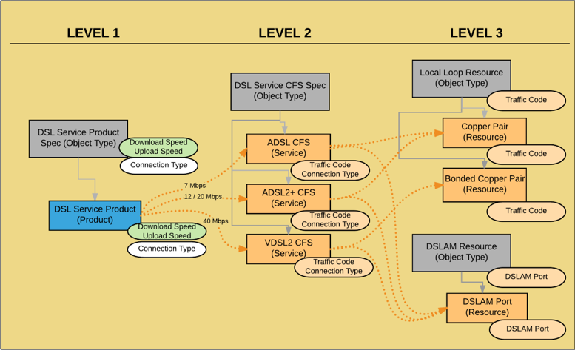

As an example, there **are two commercial products — Internet and Voice.** **Parameters that are required to activate a service are defined at the commercial product level, such as Internet or Voice,** because they are either entered manually when creating the order, or are passed from an interface.

**You decompose each product to a separate Customer Facing Service (CFS). In this example, the CFSs are not visible to customers, but serve as an intermediate interface to receive parameters collected at the order time from the product and pass the values to different RFSs.**

Decomposing a product to a CFS enables you to:

* Logically group RFSs
* Optionally create an aggregated orchestration plan at the CFS level with key milestones that you can track, and on which you can report progress. It does not replace the orchestration plan you create at the RFS level.

To fulfill each service, the system must communicate with multiple external systems in a specific order. This could include, for example, communicating with an activation engine to request configuration of network elements and performing different operations, such as resource reservation, resource inventory, and billing updates.

**In the given example, we define a set of RFSs to communicate with external systems, such as the workforce management system, delivery system, and the inventory system.**

The following is a visual representation of the described example:

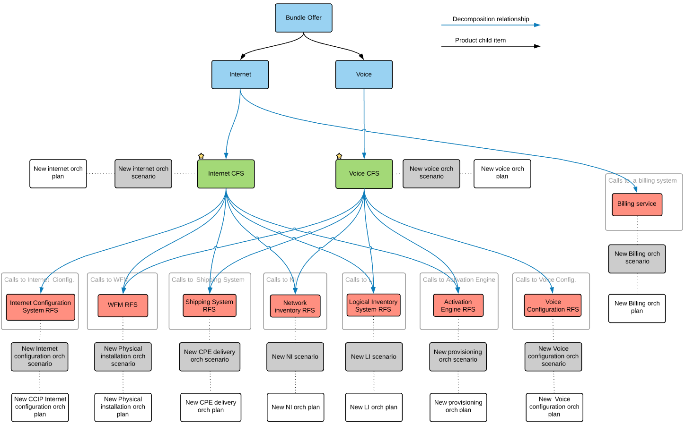

Another use of multi-stage decomposition may occur when you need to send information from multiple sources to multiple instances, such as when you need to provision TV channels individually instead of simultaneously. You may also need to send information found on the TV service. To accomplish this, you use many-to-one patterns to build a CFS from multiple sources and then use a one-to-many pattern to decompose the CFS into specific RFSs.

In Order Management Plus, field propagation in multi-level decomposition relationships is only valid for original order fields.

# Decomposition Visualization

The Decomposition View shows a color-coded tree diagram of the executed order rules, as well as the decomposition relationships between commercial and technical products.

As orders are submitted to Industries Order Management, the decomposition function starts and executes the decomposition rules. The outcome of the decomposition process includes a set of decomposed fulfillment requests that map the order line items (products) on the source order to a set of fulfillment requests (product specifications) that represent the technical items to fulfill on an order.

You can view the rules that executed as well as the inputs to the decomposition algorithm and the output. Color coding lets you quickly distinguish between items that were added to the tree as opposed to items that existed prior to decomposition. This is useful for decomposition debugging.

From an order, scroll down to **Decomposition View**. The decomposition view opens. From the top of the view, click the appropriate icon to print the entire decomposition tree, view the original order, view the orchestration plan, or (from the gear icon) see options about what information to view.

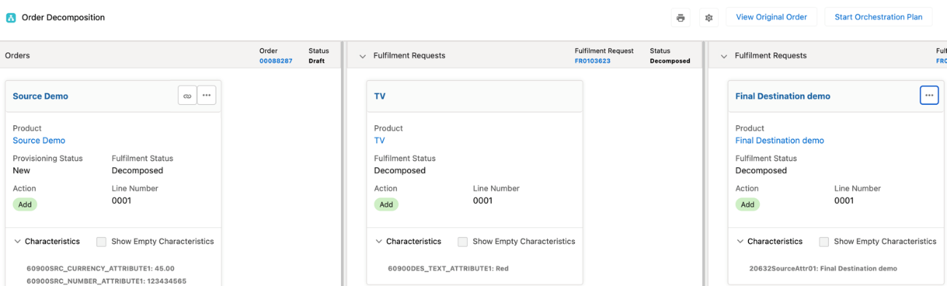

Tree views show the decomposition relationships between commercial and technical products. You can expand or collapse the attribute panels to show or hide attributes, either at the order item level or for the entire order.

The left side of the diagram shows the original commercial order (source order) that was submitted to Order Management from the order capture system.

Decomposition rules result in generation of the decomposed fulfillment requests containing technical products. These are presented as nodes on the right side of the diagram. There is only one top-level item per fulfillment request line. Click the chain icon from a source product on the left side of the diagram to highlight the corresponding decomposed fulfillment request on the right side of the diagram. Click the chain icon on the right side of the diagram to see how the product is further decomposed into additional products. For more information, see [Multi-Level Decomposition Modeling.](https://help.salesforce.com/s/articleView?id=ind.comms_t_multi_level_decomposition_modeling_230398.htm&language=en_US&type=5)

The newly generated technical products have their own child relationships, per catalog definition, that are enriched onto the decomposed fulfillment requests. You can see the relationship by clicking the chain icon for a decomposed fulfillment request. You can also define additional rules that populate attributes onto the decomposed fulfillment requests. The resulting parameters are shown nested below each technical product.

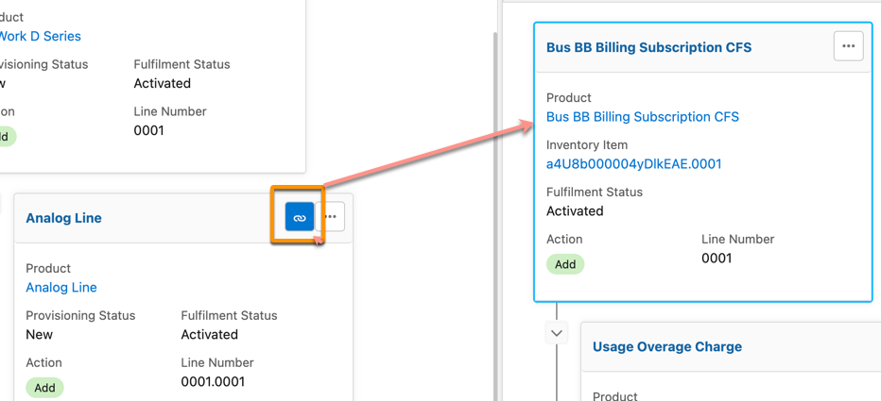



NOTE

Clicking the chain button also highlights inactive, previously linked, fulfillment requests in red.

For example, if you submitted a supplemental order to amend an existing order, but that supplemental order failed due to conditions that were set, the fulfillment request item is no longer actively related to the supplemental order. But the fulfillment request item stills appears in the decomposition view, and if you click the source item, that fulfillment request item is highlighted in red.

Click the Decomposition Relationship Definitions button (it's three dots, just to the right of the link button) to see a list of the decomposition relationship definitions associated with that item. Click one of the items in the list to see the definition.



NOTE If you don't see the Decomposition Relationship Definitions button (three dots), try changing permissions. Make sure that the following field is able to be read: Decomposition Relationship Metadata

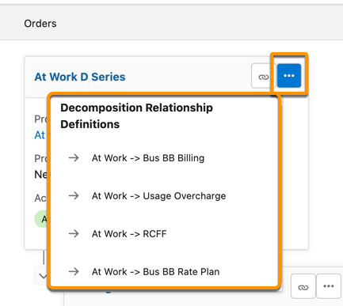

# Salesforce Actions and SubAction

In Salesforce, actions and subactions are used to identify how to fulfill an order after the decomposition process.

**Actions**

Modify

An item is given the Modify action if there's a difference in attribute values between the decomposed items and the existing inventory item.

NoChange

An item is given the NoChange action if there's no difference in attribute values between the decomposed items and the existing inventory item.

Create

A new downstream fulfillment request is added to account for the delivery of an item.

Amend

An item is marked as Amend if it has a change.

Disconnect

A fulfillment request line is given the Disconnect action if an item doesn't exist in a plan.

Add

A fulfillment request line is given the Add action if an item exists in a different plan than the one it's being decomposed from.

Subactions

Reassign: A subaction of Reassign is used when an upstream item has a subaction of either Replace or Reassign.

The decomposition process generates fulfillment requests that are tailored for specific downstream systems.

**Order Management and Change of Plan**

The CPQ Change of Plan feature allows customers to change or migrate their services and plans after their initial purchase. Order Management supports that feature, and the following examples help give an idea of how Change of Plan works in Order Management.



Note

For details about how the Change of Plan feature works in CPQ, see: [Change of Plans in Industries CPQ and Product Catalog](https://help.salesforce.com/s/articleView?id=ind.comms_change_of_plans_in_industries_cpq_and_product_catalog.htm&language=da&type=5)

Throughout this page, we use the following conventions:

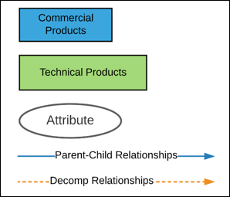

**A Simple Change of Plan**

Let's say that there are two plans that a customer can choose from: a small plan and a medium one.

* The Small plan includes: TV, Internet, and Netflix
* The Medium plan includes: TV, Internet, and Phone

So both plans include three items, but they're not the same three. The following image shows how the two plans are modeled in the catalog.

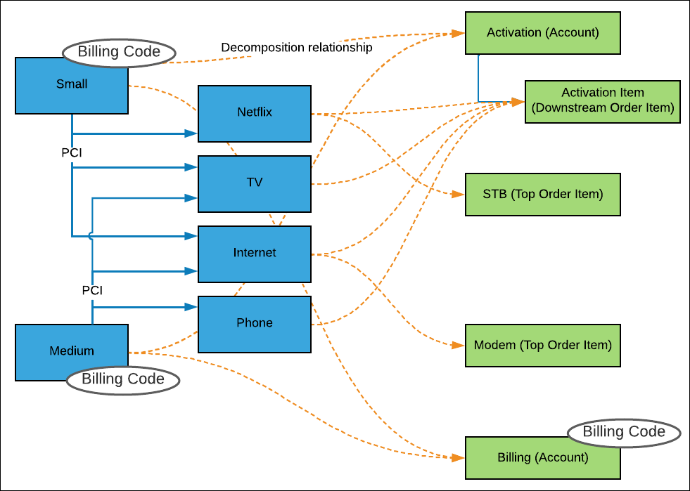

Our customer signs up for the Small plan, so we can ignore the Medium one for right now. The small plan, with its decomposition, looks like the following image. The **Small** item has a Billing Code attribute with a value of **S** (for Small).

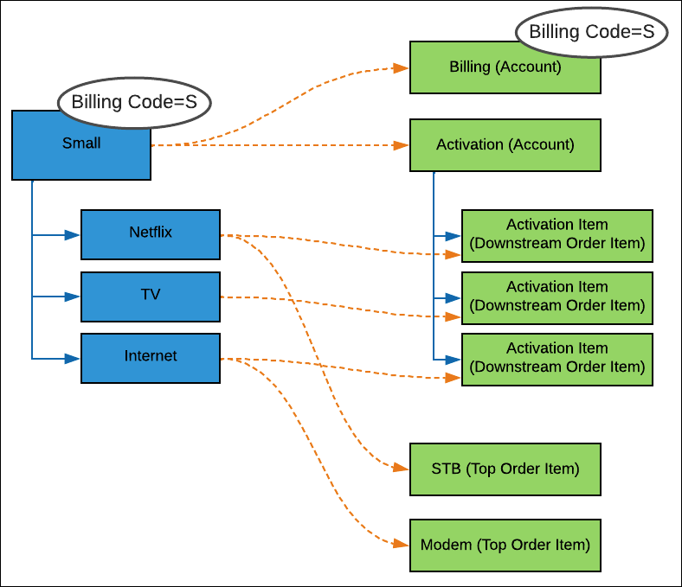

But now the customer decides to switch to the Medium plan. What does this look like in Order Management?

To keep things simple, let's start with only the order items, rather than the decomposition.

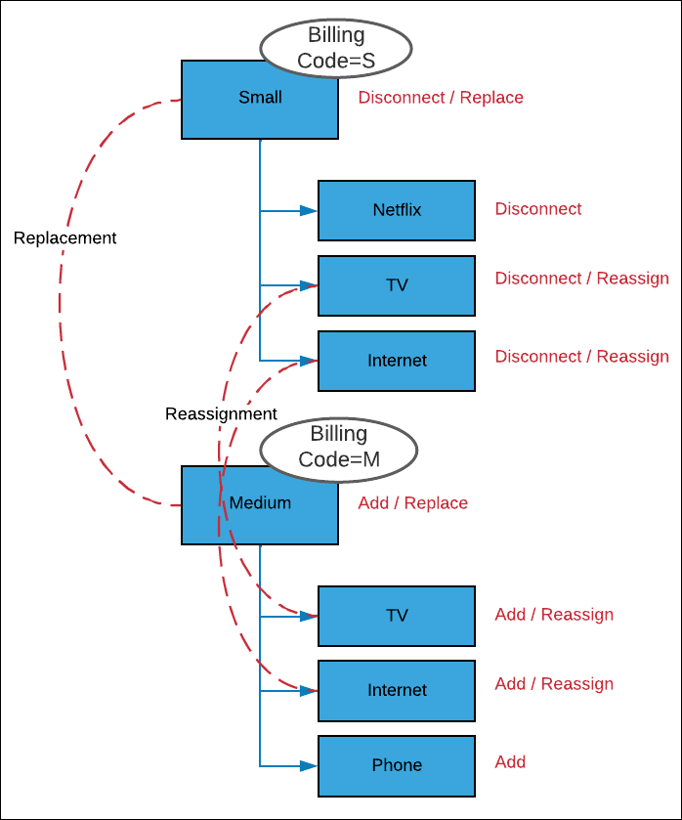

So what's happening? CPQ Management does the following things:

* Disconnects the Small plan with the subaction of **Replace**.
  + Disconnects Netflix altogether
  + Disconnects TV and reassigns it (that is, gives it the subaction of **Reassign**)
  + Disconnects Internet and reassigns it (that is, gives it the subaction of **Reassign**)
* Adds the Medium plan, with the subaction of **Replace**. The Billing Code attribute becomes **M** (for Medium).
  + Adds TV with the subaction of **Reassign**.
  + Add Internet with the subaction of **Reassign**.
  + Adds Phone

For the full picture, here's a chart showing the change including decomposition changes.

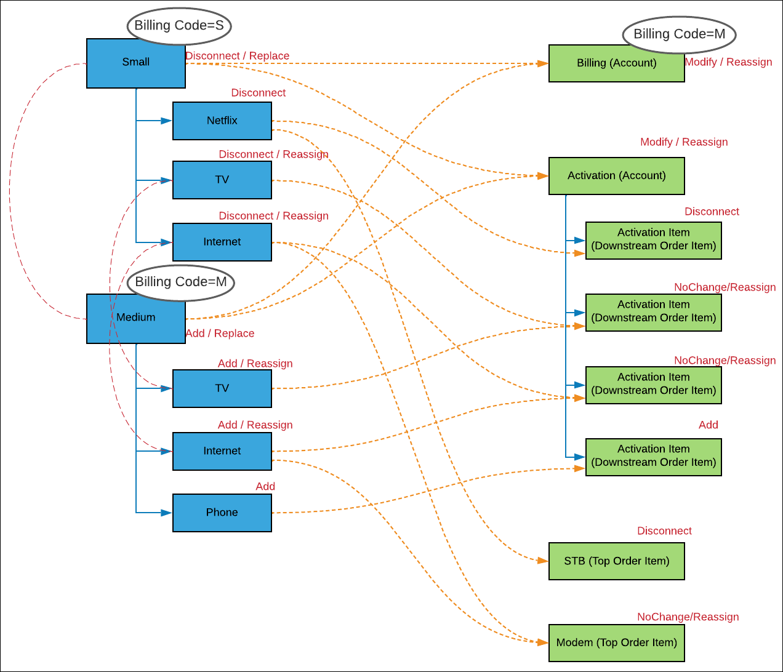

Here are decomposition rules (affecting the green boxes) that are followed during the change. Before the Summer '21 release, some of these rules were handled a little differently.

* After decomposition, the decomposed items are compared to the ones in the existing inventory item (in this case, the Small plan). If there's a difference in attribute values, then the item is given the **Modify** action. Otherwise, it's given the **NoChange** action.



Note

Parent decomposition items are given the **Modify** action if any child item has been modified.

* + Both plans have **TV** and **Internet**, so their decomposition items are marked with **NoChange**. The subaction is **Reassign**, as they're moved to the new plan.
  + **Netflix** doesn't exist in the Medium plan. So, the fulfillment request lines that are decomposed from the Netflix item (that is, its **Activation Item** and **STB**) have the action of **Disconnect**.
  + **Phone** doesn't exist in the Small plan, but is in the Medium one, so its activation item has the action of **Add**.
  + The **Activation** decomposition item is given the action of **Modify**, because it has at least one fulfillment request line (or FRL) that's being modified. In this case, it has two FRLs being modified (the ones that are decomposed from Netflix and Phone).
* Order items that are linked through order item relationships are decomposed together.
* If an upstream item (like an order item) has a subaction of either **Replace** or **Reassign**, then its downstream items have the **Reassign** subaction. If the upstream item has no subaction, then its downstream items have no subaction.
* Scopes are applied following the usual decomposition rules.

**A Change of Plan with Multilevel Decomposition**

In this case, there's a more complicated order, which has more than one layer of decomposition.

Let's say that there are three offers:

* Fiber internet: Includes Broadband, Video Streaming, and Firewall.
* VDSL internet: Includes Broadband, Video Streaming, and Email.
* ADLS internet: Includes Broadband, Video Streaming, and Email.

So they all include Broadband and Video Streaming. But whereas VDSL and ADSL include Email, Fiber includes Firewall instead. The following image shows how the three plans are modeled in the catalog.

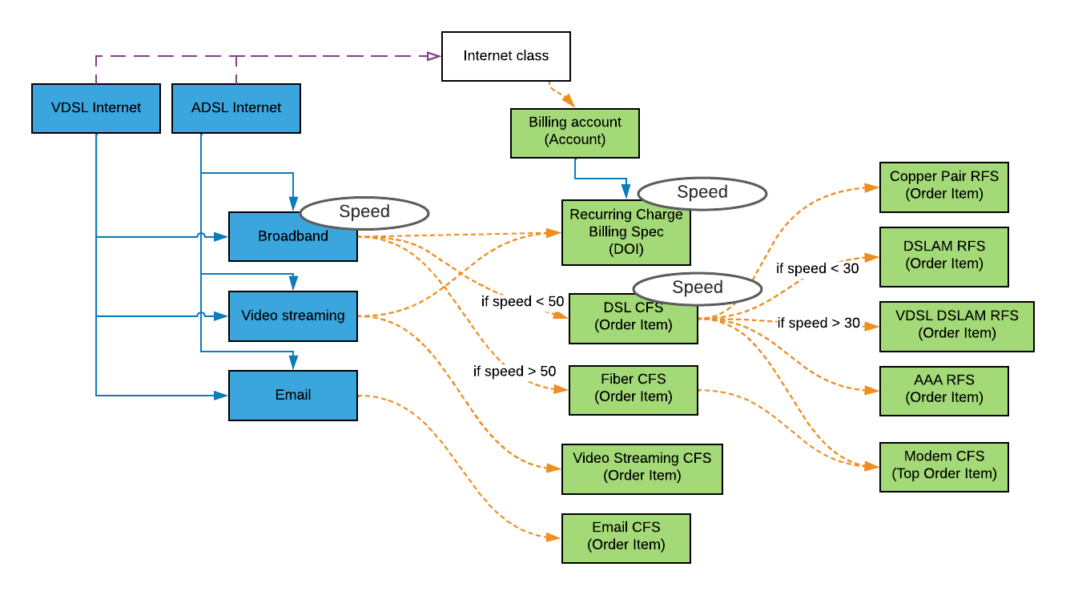

Our customer orders the ADSL plan, which includes Broadband, Video Streaming, and Email. The speed (see the **Speed** attribute) is 20 Mbps.

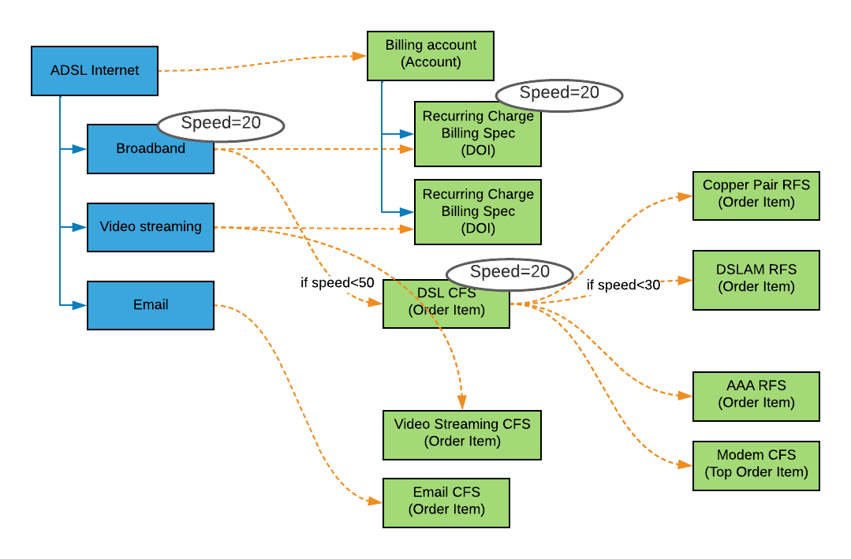

Now the customer changes the plan. They want to upgrade to VDSL, to take advantage of 40 Mbps. The change is represented in the following image:

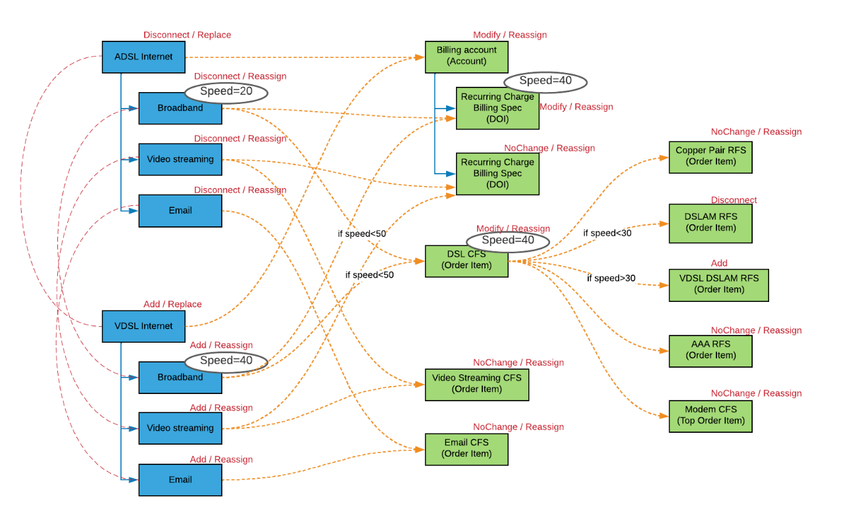

Following the same rules as for a simple change of plans, Order Management handles the change. Items change because their attributes change, or (in the case of Billing account) because one or more children change. Items that are deleted or added (for example, DSLAM RFS) have no subaction.

# Creating Technical Products

In Industries Order Management, a commercial product is any product that is visible to the customer either on the shelf or in their cart. A technical product is any product that is generally not visible to the customer but is required for fulfillment.

Technical products are used to fulfill orders, and are often defined by the requirements of the downstream system, such as billing, fulfillment, logistics, and other systems that are involved in the fulfillment process. Technical products are not always required. Commercial products that are defined sufficiently can be used for fulfillment.

Technical products should be created in the following situations:

* The commercial product entity cannot fully describe the product entity in terms that can be understood by the downstream systems.
* The details of the product entity should be masked from the customer.
* The product entity maps to a multitude of underlying products, services or resources.
* To consolidate the number of callouts to a downstream system.

Industries Order Management gives you the tools to translate commercial products to their corresponding technical products. It does this using Decomposition Relationships that map the fields and attributes of commercial products to decomposition attributes.

Technical product specifications should be defined using product attributes only. Order Management’s functionality relies on product attributes to communicate product and fulfillment information with external systems.

# Vlocity Solution in Modeling Decomposition

As a fulfillment designer, you can create a technical product to share by all products of the same class, and therefore define a single decomposition relationship once for the class instead for each commercial product.

To share decomposition configurations across multiple products:

1. Create a product with a record type “Class” and define the decomposition against this product.
2. Create new offers that reference this new class, by populating the Parent Class field with the product that you created in step one.



NOTE

If there is no Parent Class field, you can add one. See "Define a Layout with Fields and Attributes."

This type of configuration works with v15.x releases and later of OM.

Starting with the Summer 17 Release, EPC has introduced the concept of ObjectType. Catalog designers can use ObjectType to model products that share the same traits. Use of ObjectType affords inheritance among products declared of the same ObjectType. It also enables inheritance for ObjectTypes themselves. The inheritance means that an attribute defined (bound) to an object type is automatically bound to all products of that specific ObjectType. This is a very powerful concept for product designers.

The following diagram shows how attributes are inherited across a hierarchy of ObjectTypes. For more information, see [Create an Object Type](https://help.salesforce.com/s/articleView?id=ind.comms_create_an_object_type_in_the_product_console.htm&language=en_US&type=5)

**ObjectType Inheritance**

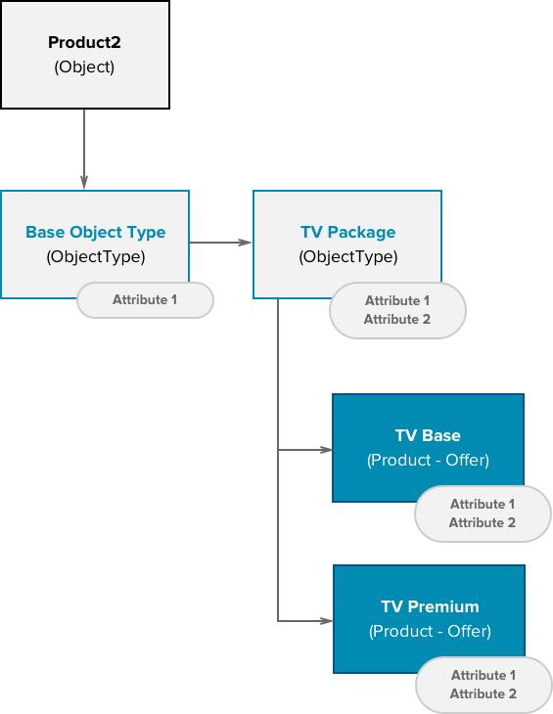

However, Order Management does not currently use ObjectTypes but does use the parent class concept. Catalog designers can take advantage of both concepts at the same time to optimize the way decomposition works.

You can use ObjectType with both commercial and technical products for more effective modeling. As previously mentioned, to enable class-based decomposition, the fulfillment designer creates a class and defines the decomposition rules against the class, then updates the offers to set the Parent Class field to point to the class.

Since the decomposition function maps attributes and fields to technical products, the class must include the same attributes and fields in its configuration. In the Summer 17 Release and later, you can use the ObjectType in the Class definition and thus inherit fields and attributes. This can greatly reduce the amount of work and provides better control of attribute definitions.

The following diagram shows a sample configuration using both ObjectType and Class.

**Completed Configuration**

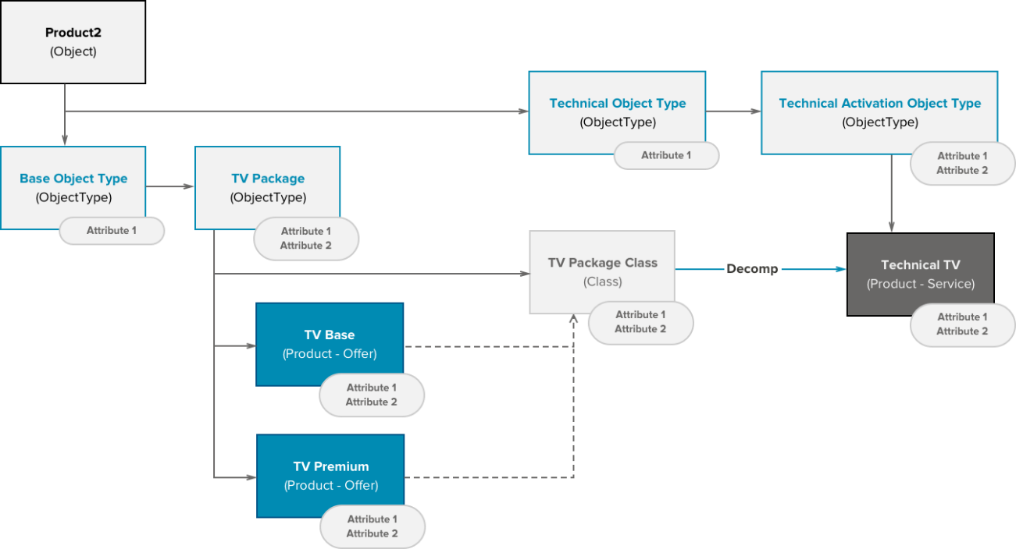

The product configuration is mostly performed through the Product Console. However, there are exceptions. The Product Console does not allow definitions of Classes, which means you must create the class in the Aloha interface.

# Orchestration Plan Definition

Industries Order Management uses orchestration plan definitions to specify how to fulfill orders across a set of fulfillment systems. Orchestration plan definitions group order processing tasks for the fulfillment requests that were created by the decomposition process.

É o plano de de orquestração propriamente dito

# Orchestration Scenarios

Industries Order Management uses orchestration scenarios to determine when an orchestration plan definition should execute. Define an orchestration scenario by specifying a product entity and an order action such as Add, Modify, Disconnect, or NoChange.

É mapear as regras de decomposição com o plano

# Orchestration Items

Orchestration items represent the tasks and activities in an orchestration plan that are performed during the order process, and they are grouped by an orchestration plan definition.

At runtime, orchestration item definitions become orchestration items, and the orchestration execution engine monitors their state. The state process flow for orchestration items is shown in the diagram:

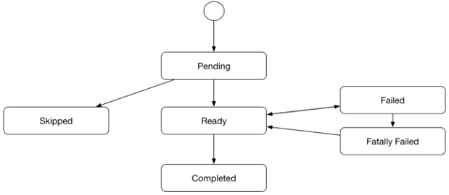

# Technical Inventory

Technical Inventory refers to all the items, such as inventory items, in the Technical Catalog.

The Technical Catalog defines Technical Specifications, which is a generic term for the definitions of services and resources that are not commercially exposed, but are needed to fulfill the commercial requests. The Technical Specifications are defined as Products. Configuration Specialists can use the full power of the Enterprise Product Catalog. However, unlike commercial product specifications, for technical specifications, you can use only attributes and not fields. The Technical Inventory and its inventory items only apply when deploying Vlocity Order Management.

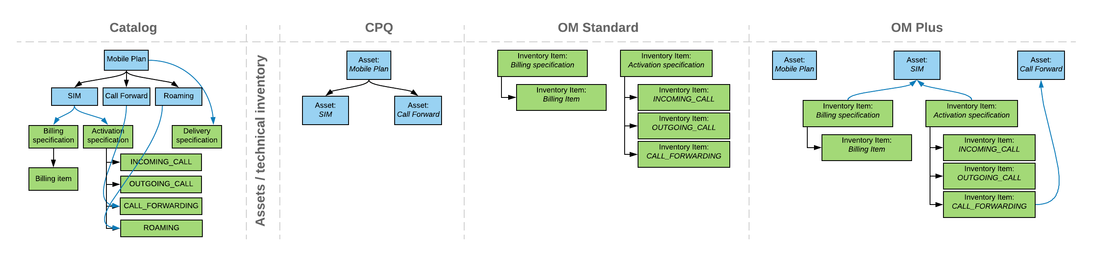

**DID THIS ARTICLE SOLVE YOUR ISSUE?**

Let us know so we can improve!

YesNo

# How Technical Inventory Works

You can define commercial and technical product specifications, including cardinality rules, in the Enterprise Product Catalog. CPQ uses these definitions to drive the order capture process that results in an Order with Order Items.

Each Order Item is a wrapper for a product instance and becomes an asset. Orders processed by Order Management are first decomposed. **During the decomposition process, Order Management generates a list of Fulfillment Requests, each of which contains Fulfillment Request Lines, by running the configured decomposition rules on the order. The Fulfillment Requests are essentially wrappers for technical product instances.**

The resulting decomposed order is then fulfilled by creating and executing an Orchestration Plan specific to the order. Typically, orchestration plans invoke a process of assetization after all provisioning and billing has been completed. This is done through a special orchestration item that invokes managed package code that persists the commercial side of the order in the Assets table and persists the technical side of the order in the Inventory Items.

To avoid having a technical item persist as an inventory item, a fulfillment designer enables the notAssetizable flag for that technical item. To avoid having an order item assetize, the designer must both enable the notAssetizable flag for that item and set a filter in the FieldMapper.

The image is a high level diagram of the relationships between the components and objects.

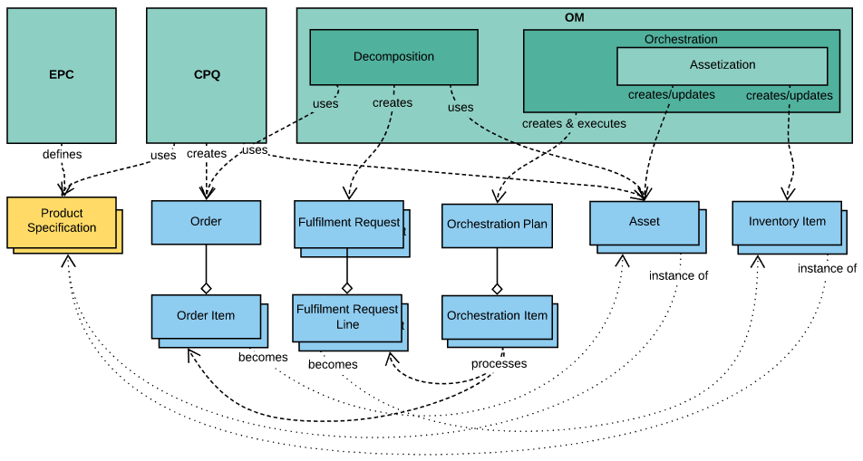

The following diagram illustrates the lifecycle of the inventory items:

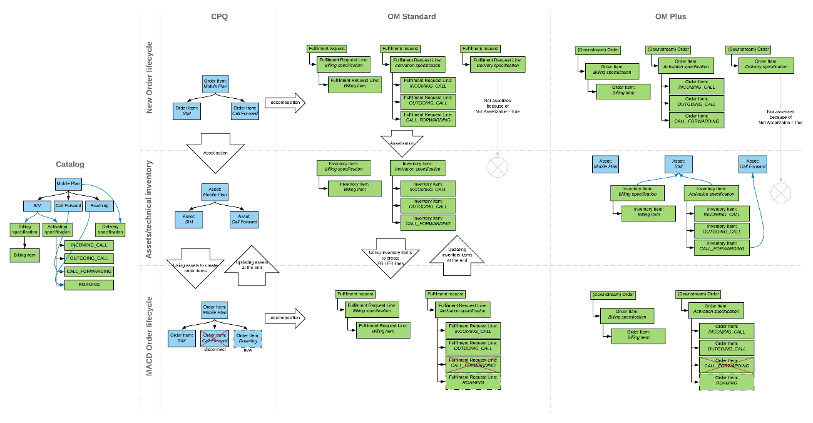

# Impact of Technical Inventory on Fulfillment

The Inventory Items are objects stored in the database and modified during fulfillment. As such, they keep their values in-between orders.

**The Fulfillment Request Lines generated for technical products are used during fulfillment. They can build the payloads for the callout sent to external fulfillment systems. Fulfillment Request Lines can store and maintain data, which is transient and does not need to be assetized or copied to the corresponding inventory item.** There aresituations when you need to propagate data from Fulfillment Request Lines to Assets for reporting purposes, or for Customer Service Representatives to use later.

**Tempo de carrinho**

**order ->** toda ordem gera um registro na order

**orderitem ->** Depois que a order é criada e o produto é inserido no carrinho, a ordem item é gerada com base no produto e atributos.

**Decomposição**

**vlocity_cmt__FulfilmentRequest__c ->** É gerado o FR, que basicamente são os registros com todos os FRL resultantes das decomposições entre produto comercial e tecnico.

**vlocity_cmt__FulfilmentRequestLine__c ->** É gerado a partir da FR, e ja contem todos os atributos e informações tecnicas baseado na decomposição

produto comercial -> tecnico que foi realizada

**Orquestração**

**Orchestration Plan** -> É criado um plamno de orquestração com todas as atividades previstas

**Orchestration Item** -> É criado os itens de orquestração, que utiliza como base o fulfilmentrequestline, que é a decomposição por produto. O Orchestration Item basicamente processa o FulfilmentRequestLine.

Ao final, **o fulfilment request line** vira um registro da **inventory item(tecnico)**. A **Order Item** vira um registro da Asset(comercial).

Todas vez que faco um MACD, a decomposição pega os registros da **Asset** e coloca em estado de "edição", incluindo esses registros na **order item**. Quando

submetemos o pedido o ordering **compara** as informações de atributos da **order item** com o a **inventory** item, e se tiver diferenças gera o **fulfilment request**

**line atualizado** para ser usado na decomposição.

**Inventory Item e correlacionamento com a Asset em uma ordem**

Quando submetemos uma ordem, no processo de decomposição associamos um produto comercial(source) que é escolhido no carrinho a um produto técnico. Se esse produto técnico for assetizavel, ao termino do processamento da ordem gerara um registro de inventory item

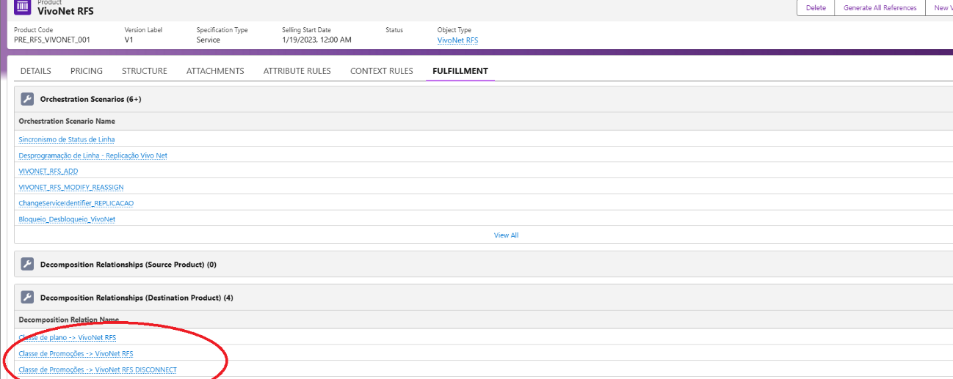

Ex de um decomposition relationship

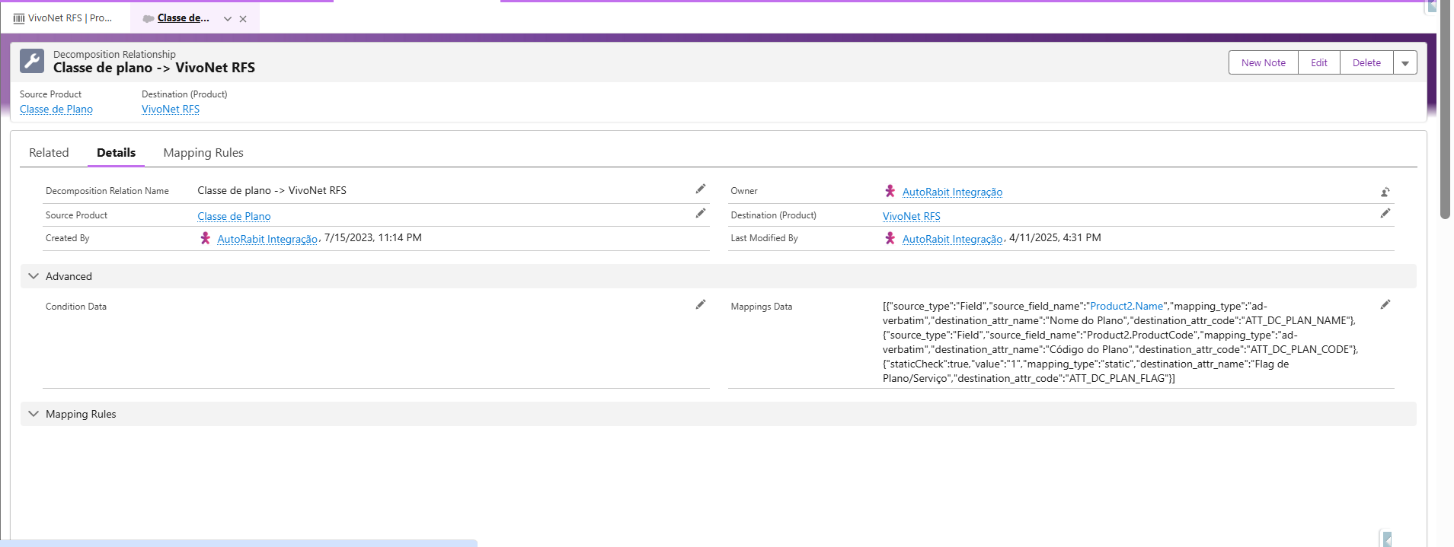

Quando ocorre a decomposição, conseguimos ver no order decomposition as decomposições do produto comercial

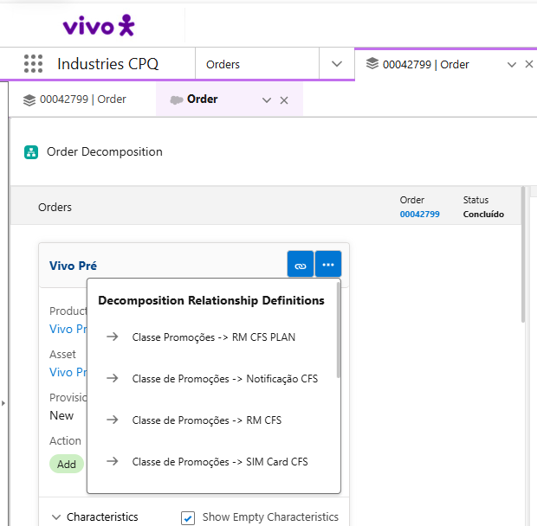

E se for um produto técnico assetivavel, ao termino do processamento sera gerado o registro na inventory item dessa forma

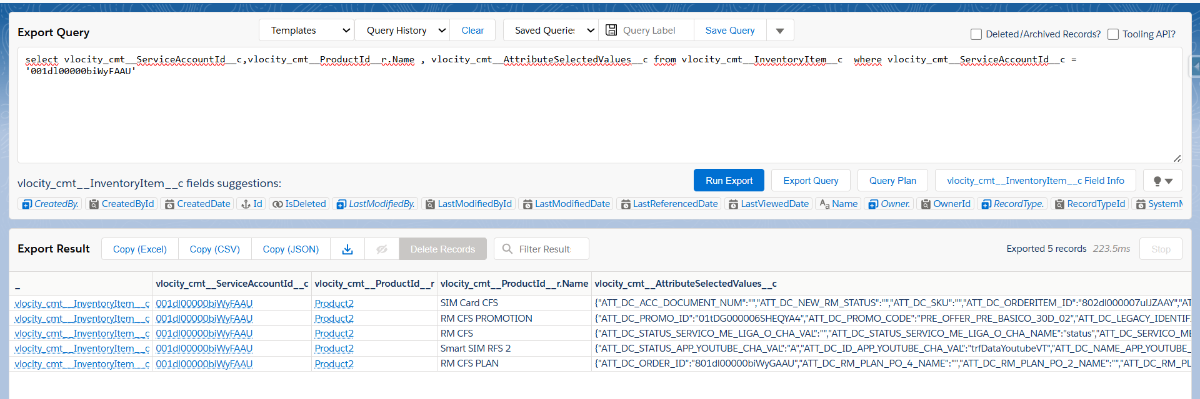

Quando é enviado uma ordem de MACD, o processo de decomposição valida se algum produto comercial que esta associado ao técnico já assetizado, teve algum atributo alterado....e essa validação se da com o batimento através da inventory item. Se sim, ele gerara um novo fulfilment request que atualizara o valor da inventory item ao final da orquestração. O que o une o registro da asset ao inventory item, é o campo serviceaccount(conforme a query acima). Não se se isso e uma regra fixa ou se pode haver variações

Those three item are enough to build a complete orchestration plan

Orchestration Plan Definition

Orchestration Item Definitions

**Orchestration Dependencies(geralmente dentro dos callouts na aba related)**

EPC

1) Começa criando picklists, e para cada picklist definindo seus possiveis valores

2) Cria-se os atributos, definindo seus nomes e tipos. Pode-se associar as picklists aos atributos

3) Cria-se object types, pode-se associar qualquer atributo e campos a estes object types

4) Cria-se products em cima dos objects types. Se for um produto simples, por convenção o produts specification = produto e o specification sub type =

simple. Esses seriam o CFS(a confirmar). Nesses produtos definiriamos caracteristicas padrão e permanente do produto.

5) Cria-se ofertas. Product specification = offer e specification sub type = bundle. Podemos ter x ofertas com caracteristicas especificas, sendo um guarda-chuva,e

tendo o produto abaixo no bundle com suas caracteristicas permanentes.

6) Cria-se as Product Class. No objeto Product2 do Vlocity Product designer, é so clicar em novo e criar a Product Class seguindo o object type do objeto que vc deja espelhar. Depois disso você associa todas as ofertas dentro da Product Class, e posteriormente colocar as regras fulfilment na Product Class. Com isso não precisarmos criar regras de decomposição por produto...mas somente na Product Class

Promoções no Salesforce esta como offer e bundle. Pacotes e Plano estão como offer e simple, mas deveria estar como bundle.

Quando esta como orderable é porque é possível velo no catalogo comercial.

Quando esta com IsCustomerSubscription é porque na ativação insere um registro na subscription.

Oferta B

Oferta A

20giga

10mi

Produto

Produto

100miOI

10giga

I) Vlocity Product Designer é o antigo onde configuravamos todas as parametrizações. Context Rules é ainda nele.

II) Vlocity Product Console é aonde mapeamos as regras de produto(LWC mais recente)

A query abaixo retorna todos os atributos e seus tipos:

select Name, vlocity_cmt__AttributeCategoryCode__c, vlocity_cmt__AttributeCategoryName__c, vlocity_cmt__Code__c from vlocity_cmt__Attribute__c order by vlocity_cmt__AttributeCategoryCode__c desc

Temos os tipos:

ATC_TECHNICAL que é um atributo técnico, que compõe o por exemplo os serviços de rede: “Status de Aprovisionamento”, “Flag de Interceptação” e mais um monte de informações

ATC_TARIFFS que é atributo para tarifação. Não sei ao certo onde se utiliza

ATC_SIM_CHARACTERISTICS Informações do chip como msisdn, iccid, Tipo de Tecnologia e IMSI.

ATC_SERVICES que aparentemente são os serviços de rede que vao para o Smart Sim. Necessario entender o porque temos duplicado com o ATC_TECHNICAL, pois temos aqui: Interceptação para URA Cadastro, Serviço de Caixa Postal, Volte e etc.

Sobre os object types, esses são os principais de negócios que utilizamos.

Pacotes Pré-pagos

Planos Pré-pagos

Promoções Pré-pagas

Bônus Pré-pagos

Recargas

**Order Management**

1. Decomposição
2. Configuro todas as promoções na product2, e crio uma classe de promoções associando todas as promoções a essa classe.
3. Com a classe de promoção aberta no Vlocity Product Deisgner, na aba de fulfilment eu crio as regras de decomposição, mapeando a oferta comercial com a oferta técnica(RFS), aos campos com o de para e os condicionais. Caso não tenha condicional sempre que a promoção for selecionada a decomposição sera executada

Decomposições criadas

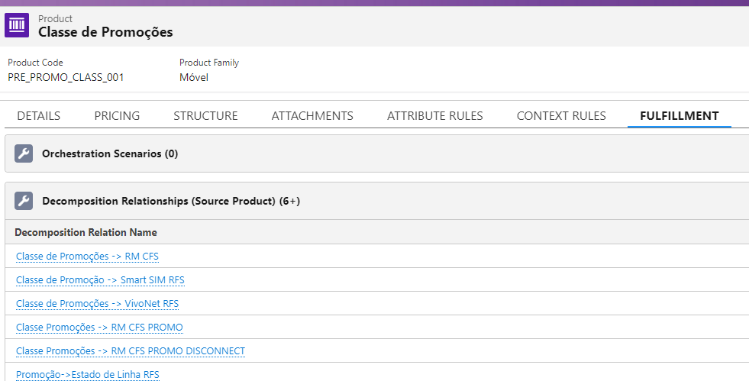

Umas das decomposições abertas, com os seus de para de campo entre produto e RFS + o condicional que definira a sua execução.

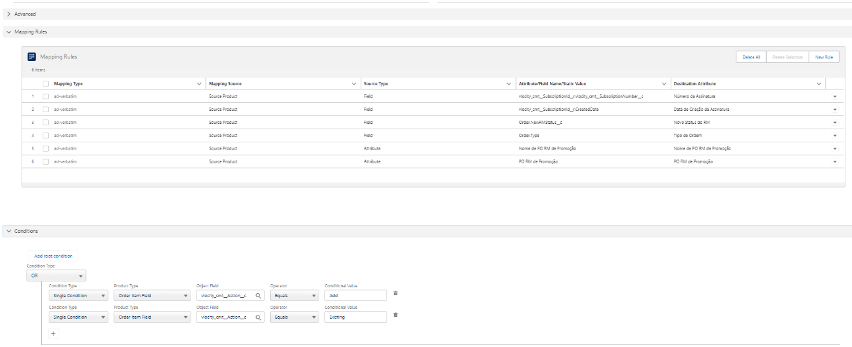

1. Com o pedido submetido e a ordem gerada, consigo ver o plano de decomposição gerado com o produto e o CFS associado que no Valentina tem sido o sistema. No exemplo abaixo o produto VivoNet RFS possui informações preenchidas a partir de 3 regras de decomposição diferente

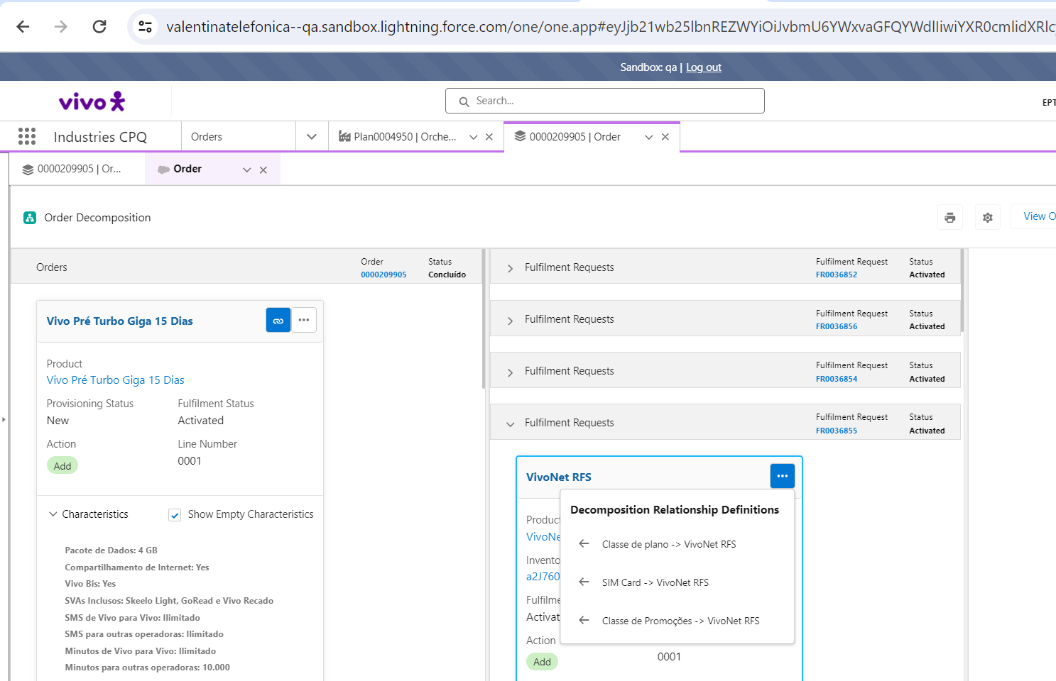

1. Todo RFS gerado possui um fulfilment request que é gerado com o seu numero. Preciso entender no omniscript de gravação do pedido como é gerado, mas toda ordem gera um orchestration item baseado em um callout e um fulfilment request que não fica associado a ordem no objeto tbm.
2. Orquestração.

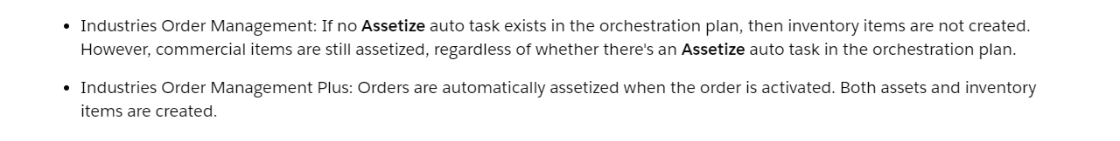

1. Orchestration Plan Definition é o responsável por criar o plano e sequencializar as chamadas dos orchestration itens

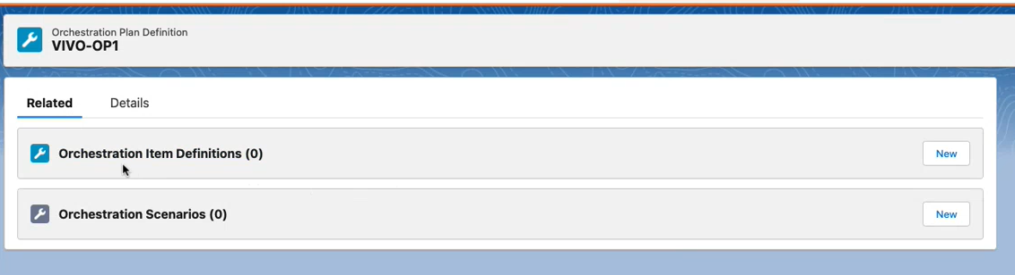

* 1. Orchestration Item é o responsável pelas chamadas/callout para os sistemas externos, ou mesmo outros tipos de atividades no Sales(Autotask, milestone)

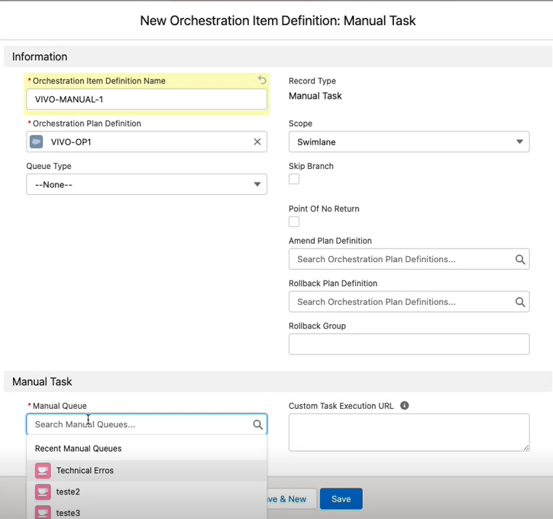

* 1. Orchestration Scenario -> Define qual o cenário(ações e produto que servem de base para trigar esse plano de orquestração)

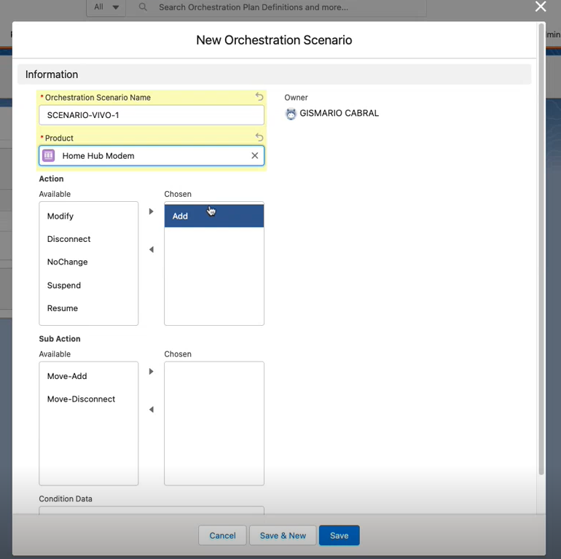

Sempre que o produto acima for selecionado no carrinho, esse plano sera trigado. No caso do Valentina o que fizemos foi colocar uma Product Class conforme explicações acima do EPC. Essa Product Class é que fica associado ao cenário, e abaixo do Product Class temos todos as ofertas filhas de fato.

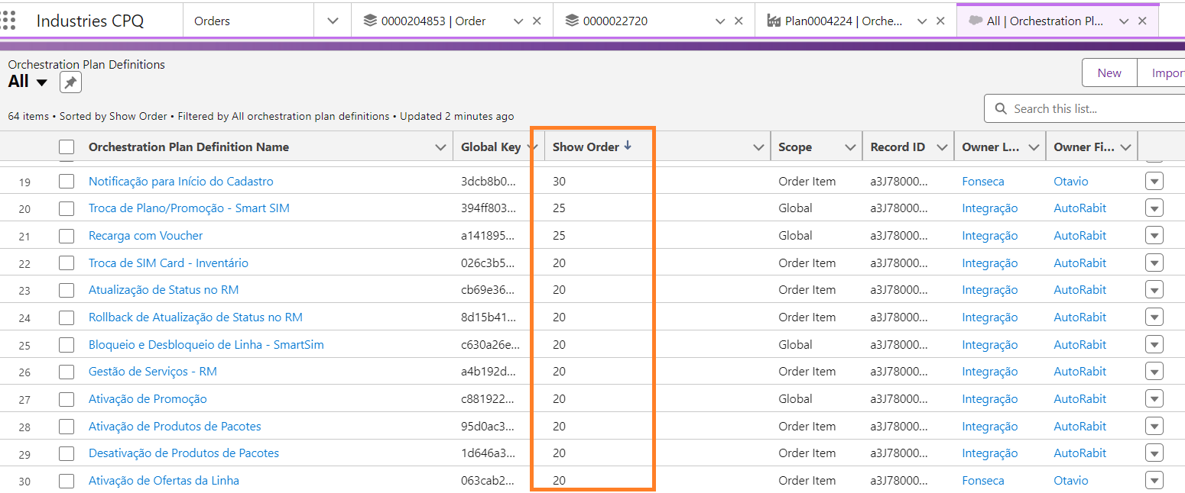

Acima esta como é executado(priorizado)a ordem dos orchestration plan.

No produto que esta associado ao orchestration scenario, temos o decomposition relationship, que basicamente é aonde mapeamos o produto comercial com o produto técnico que sera utilizado para o callout compor a request para o sistema de destino.

No Decomposition relationship podemos ter condições, uma vez que aquele mapeamento de produto comercial para técnico só possa ser executado em condições especificas. Um produto técnico(destino) pode ser populado por diferentes produtos comerciais(origem), logo pode ter mais de um decomposition relationship.

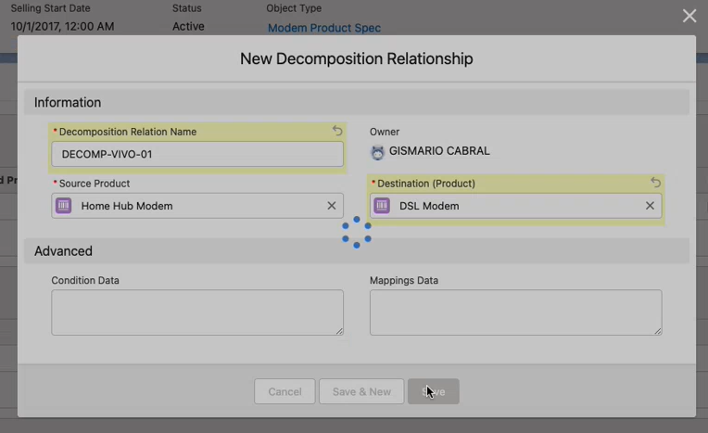

No Valentina o produto de origem é sempre a classe de promoção com o CFS/RFS

Quando clicamos no cadeadinho no plano de decomposição, conseguimos ver o produto comercial e o técnico(rfs/cfs) gerado.

Caso queira criar um **Product Class**, esse é o caminho no vlocity product designer:

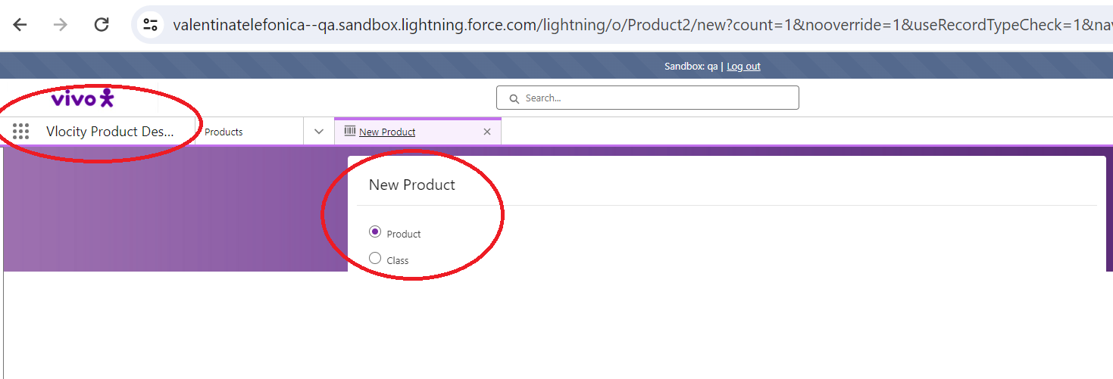

**Decomposição da ordem:**

1. Configuro todas as promoções na product2, e crio uma classe de promoções associando todas as promoções a essa classe.
2. Crio também todas as ofertas técnicas(RFS), no catalogo de produtos. Essas são simples e não entram como classe de produtos.
3. Com a classe de promoção aberta no Vlocity Product Deisgner, na aba de fulfilment eu crio as regras de decomposição, mapeando a oferta comercial com a oferta técnica(RFS), aos campos com o de para e os condicionais. Caso não tenha condicional sempre que a promoção for selecionada a decomposição sera executada:

Para criar uma Classe de Produtos



Caso selecione produto e queira que ele pertença a uma classe, é só mapear no campo Parent Class

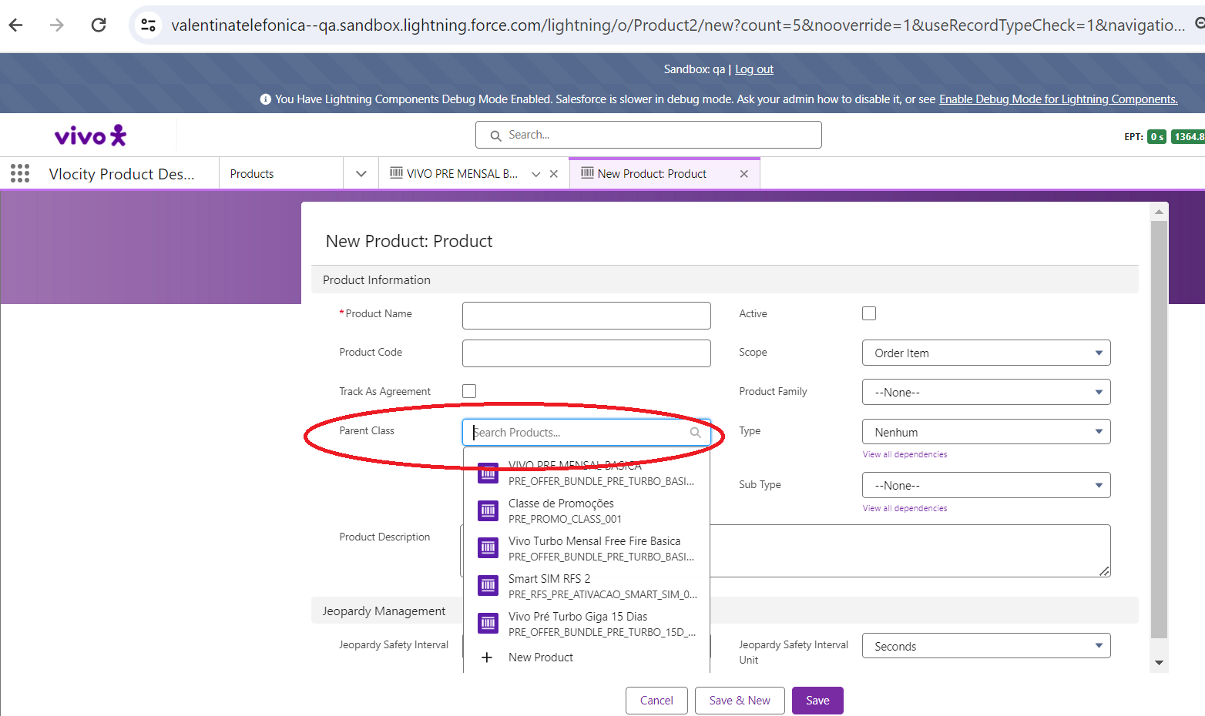

Abaixo a classe de promoções(CFS) com todas as decomposições criadas e associadas a um produtos técnico(RFS). Por ser o produto de origem(que o cliente selecionada), a decomposição aparece no Source Product

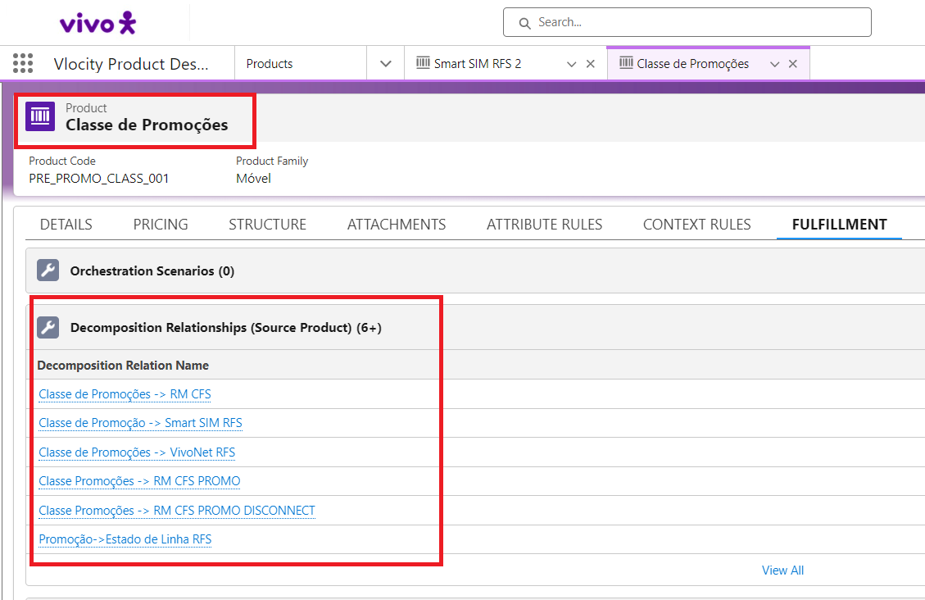

Abaixo como exemplo o produto técnico RM CFS PROMO que foi decomposto pelo produto comercial. Não configuramos regras de decomposição para o produto técnico, ele herda o do comercial, e fica referenciado no Destination(target) product.

**\*\*Orchestration Scenario ainda não vou falar aqui na decomposição.**

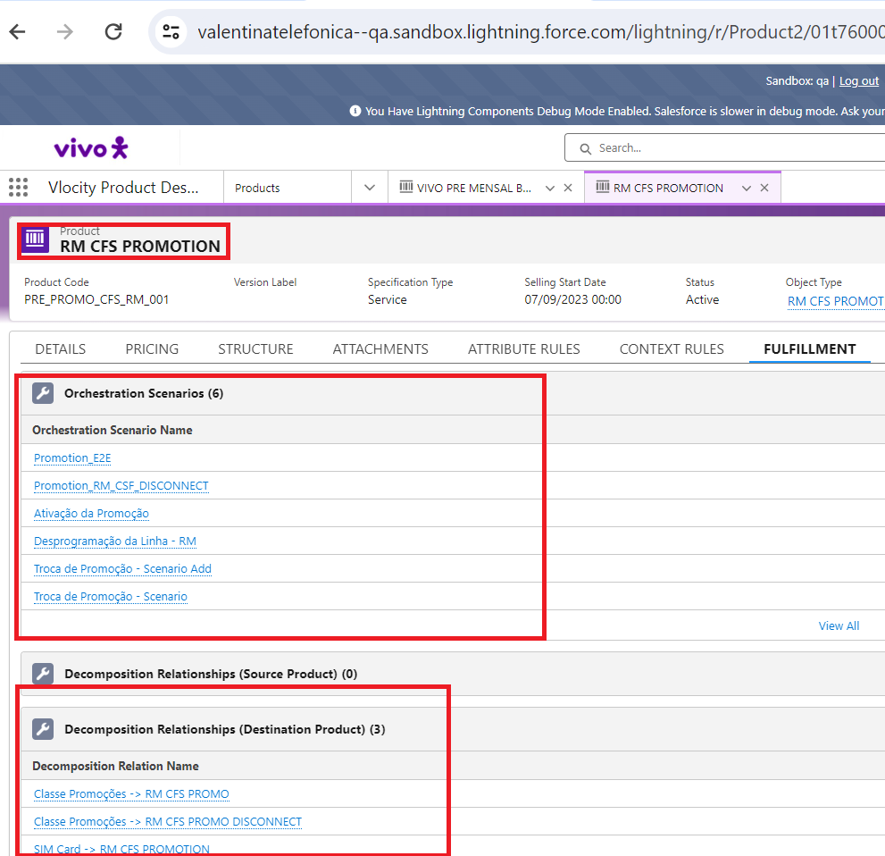

Abaixo o exemplo de mapeamento de campos entre produto comercial e técnico ao clicar sobre uma das regras de decomposição

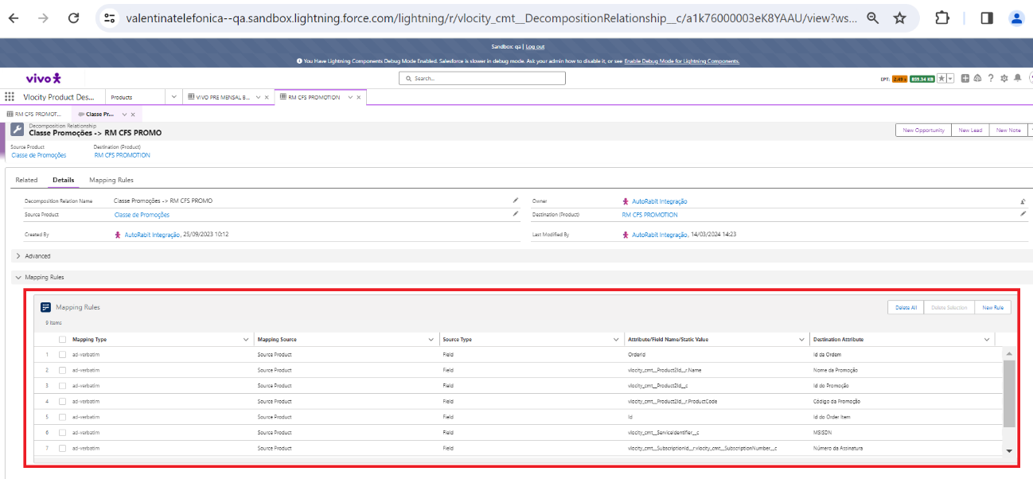

Abaixo o condicional que é criado para triggar essas regra de decomposição entre o produto comercial e o técnico

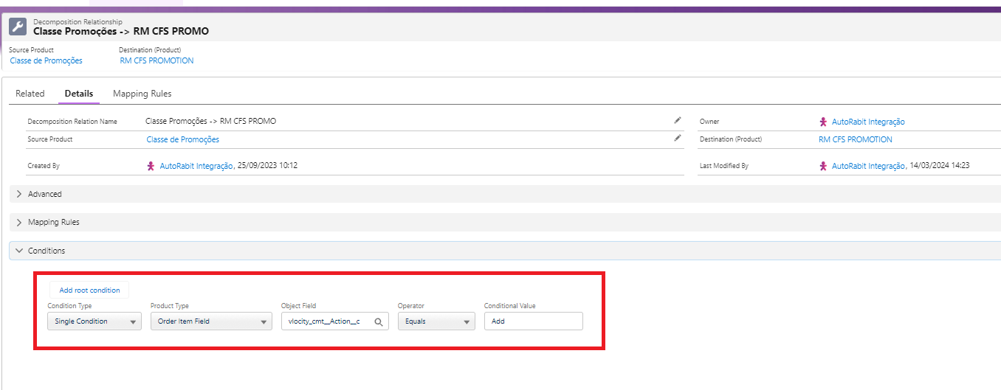

Assim que a ordem de vendas é submetida o que aparecera no plano de decomposição são todos os produtos técnicos que foram decompostos na seleção do produtos comercial(aba fulfilment da classe de promoções), e se for um bundle, todos os produtos abaixo do principal terão uma regra de decomposição também onde aparecera o produto técnico. Caso não tenha regra de decomposição sempre sera decomposto. Abaixo um exemplo do produto comercial e técnico associado no plano de decomposição

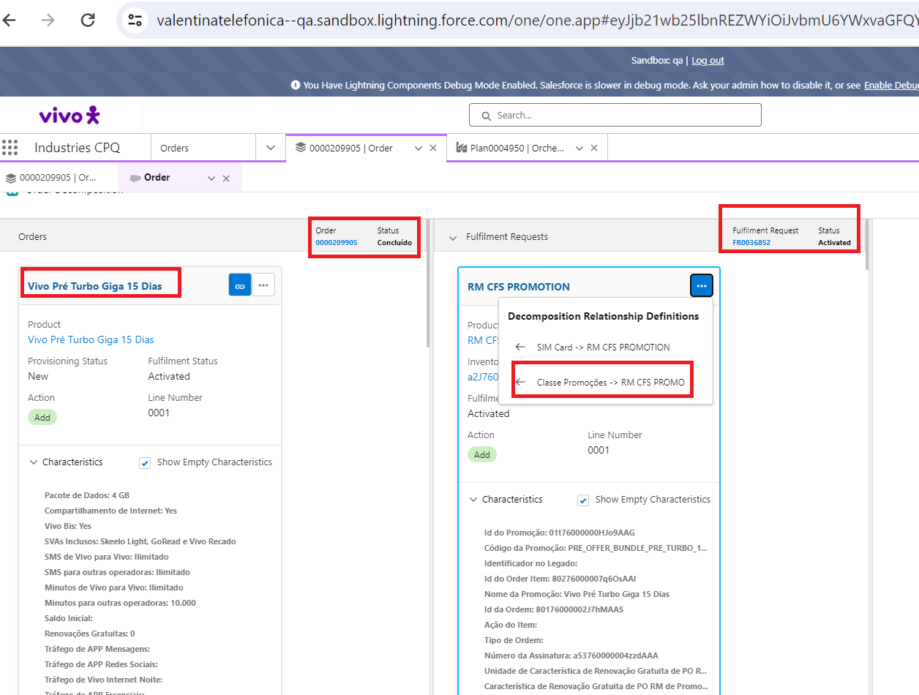

Para cada produto técnico que é decomposto, é gerado um registro fulfilment request que contém todas as informações com atributos e campos salvo em objeto referente aquela decomposição. Esses campos/atributos são populados a partir do produto comercial selecionado(considerando a modelagem do object type) no carringo, e são enviados para o técnico no data mapping da regra de decomposição. Seria possível no data mapping passar um valor fixo tbm. Todo produto técnico(RFS) gera um registro na fulflment request line.

Apenas lembrando que isso ta errado, essa modelagem não poderia ser assim(produto como serviço no catalogo). Mas é como esta.

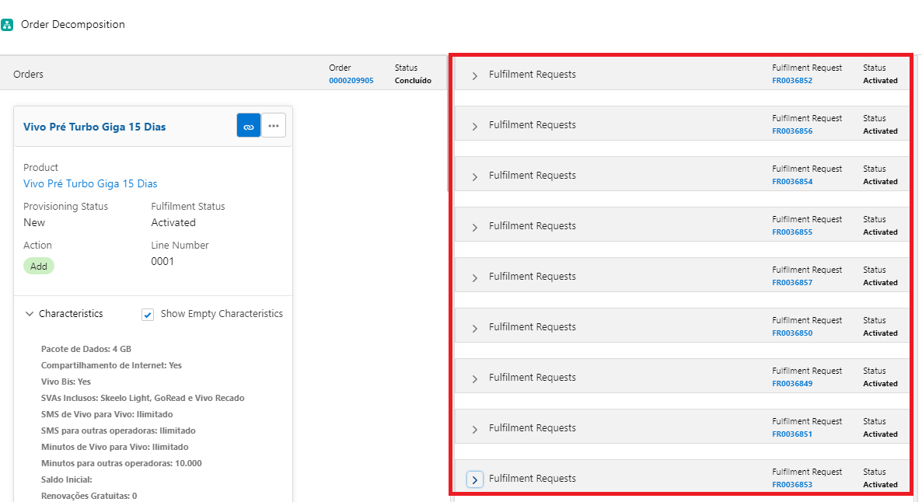

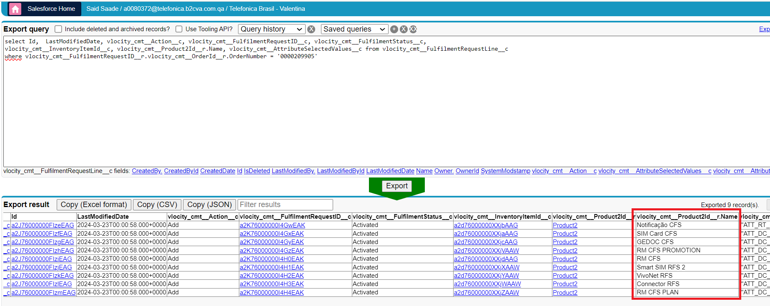

Com a query abaixo é possível ver todos os registros com produto técnico gerado a partir de um numero de ordem

select Id, LastModifiedDate, vlocity_cmt__Action__c, vlocity_cmt__FulfilmentRequestID__c, vlocity_cmt__FulfilmentStatus__c,

vlocity_cmt__InventoryItemId__c, vlocity_cmt__Product2Id__r.Name, vlocity_cmt__AttributeSelectedValues__c from vlocity_cmt__FulfilmentRequestLine__c

where vlocity_cmt__FulfilmentRequestID__r.vlocity_cmt__OrderId__r.OrderNumber = '0000209905'

**Orquestração da Ordem:**

1. Orchestration Plan Definition é o responsável por criar o plano e sequencializar as chamadas dos orchestration itens. Todos Orchestration Plan Definition criado ele vira um swin lane no plano de orquestração

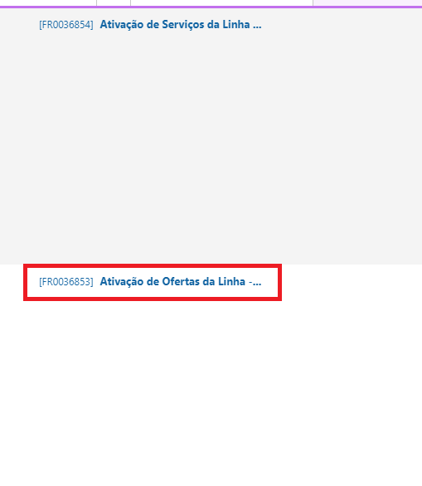

Com o orchestration plan definition aberto temos 2 itens:

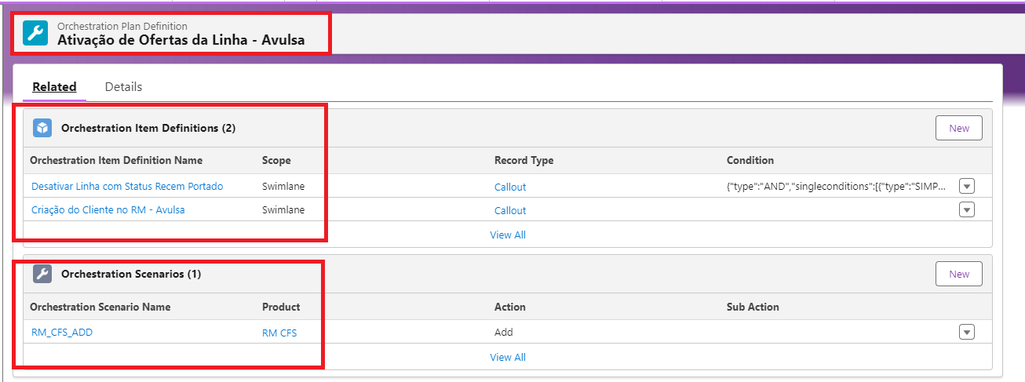

* Orchestration Scenarios:

Contém a regra de decomposição desse orchestration plan definition e sempre tem que estar associado a um produto técnico (RFS). È a partir dessa associação que o registro da fulfilment request line gera o registro do orchestration item, que comporara o callout para o sistema externo(a seguir dou mais detalhes).

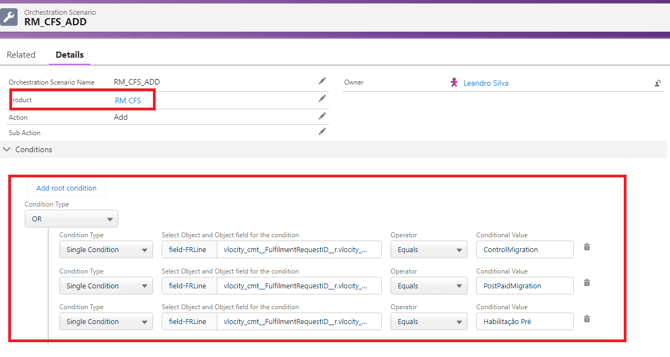

Abaixo as associações do produto técnico do plano de decomposição com o item do plano de orquestração. Isso de as através do produto técnico preenchido acima.

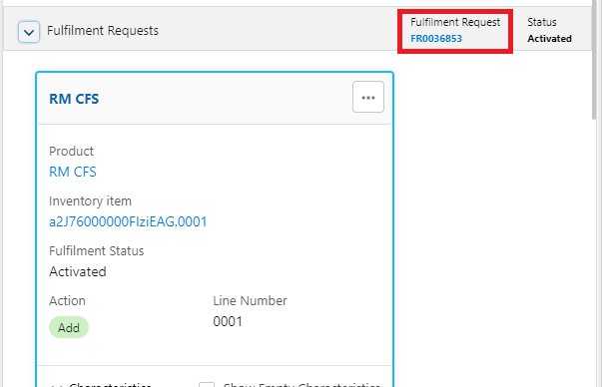

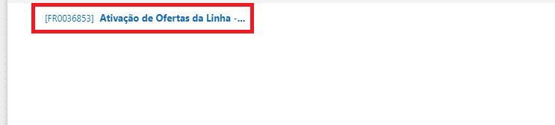

Com a query abaixo é possível ver a correção do fulfilment request line com o orchestration item. 1 fulfilment request line pode estar associado a mais de 1 orchestration item, uma vez que 1 produto técnico pode ter informações suficientes para mais de 1 callout. Na query abaixo é possível ver essas correlação.

select Id, LastModifiedDate,vlocity_cmt__FulfilmentRequestLineId__r.Name, vlocity_cmt__IsPointOfNoReturn__c,

vlocity_cmt__OrchestrationPlanDefinitionId__c, vlocity_cmt__Request__c, vlocity_cmt__Response__c, vlocity_cmt__Scope__c, StatusCode__c,

vlocity_cmt__OrchestrationItemType__c from vlocity_cmt__OrchestrationItem__c

where OrderNumber__c = '0000209905' and vlocity_cmt__OrchestrationItemType__c = 'Callout'

* Orchestration Item Definition

Contém as tarefas/itens que serão executados no plano de orquestração. Pode ser um callout, um milestones, auto task, push event e etc. Para Callout, é nele que temos o nome da ip que sera a responsável por chamar o sistemas externo, com regras de retry, filas entre outras coisas. Pode ser configurar um retry especifico ou colocar uma politica de retry tbm baseado em regras maiores que pode ser entendida no help da Salesforce

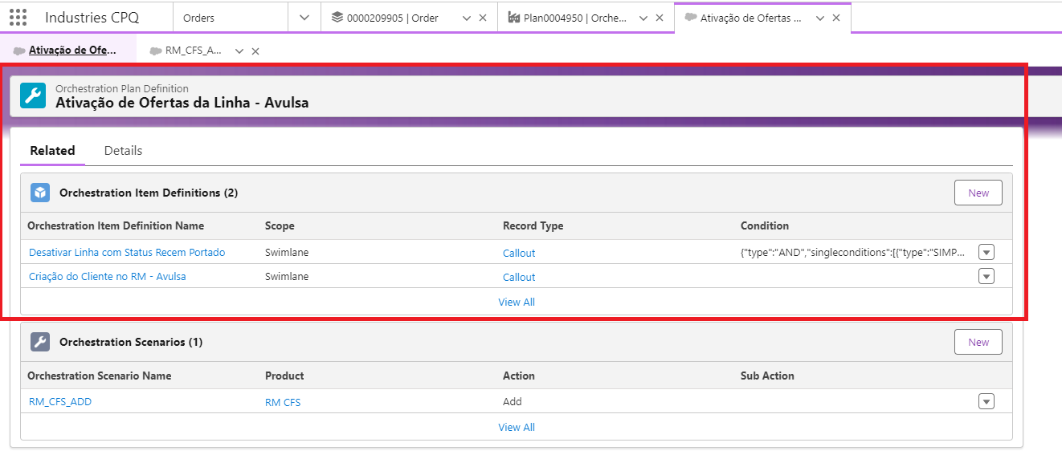

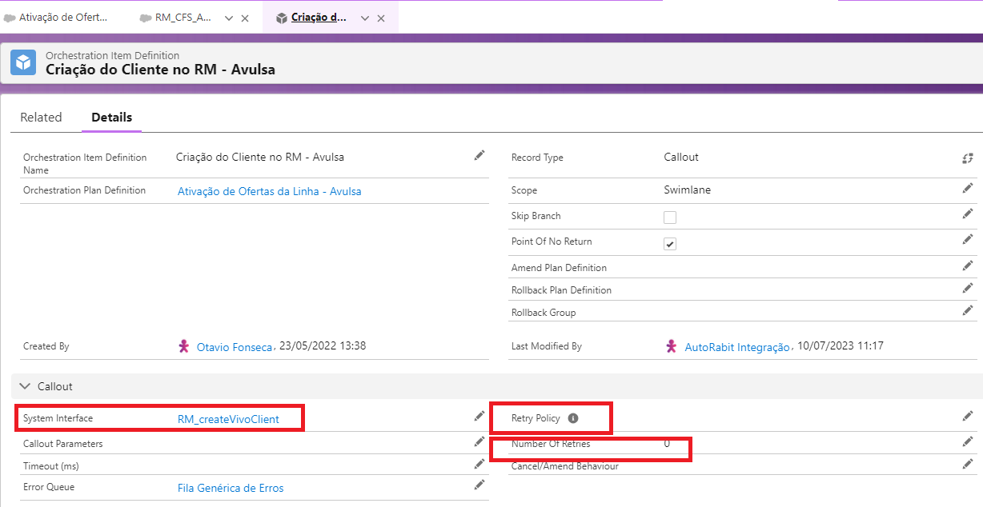

Caso queiramos colocar regras para um callout que pertence ao orquestration plan definition não seja executado(somente em cenarios especificos), é possível também inserir regras/condições

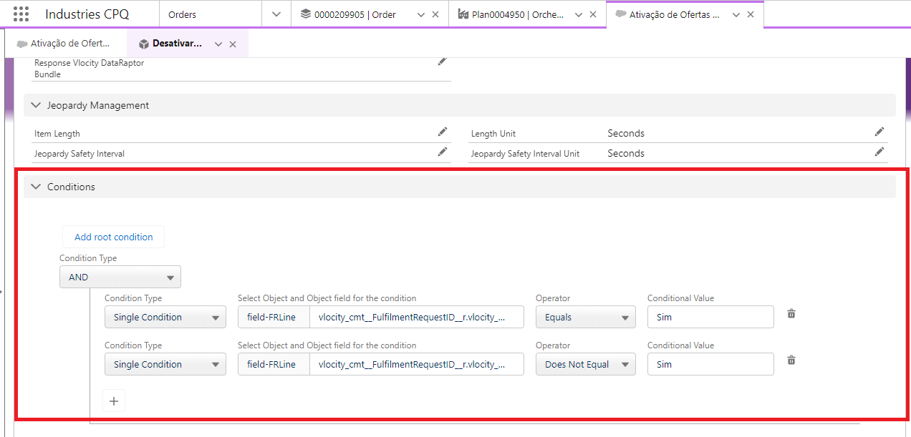

E na aba related do orchestration item definition é que mapeamos as dependencias das execuções dos itens nas ordens

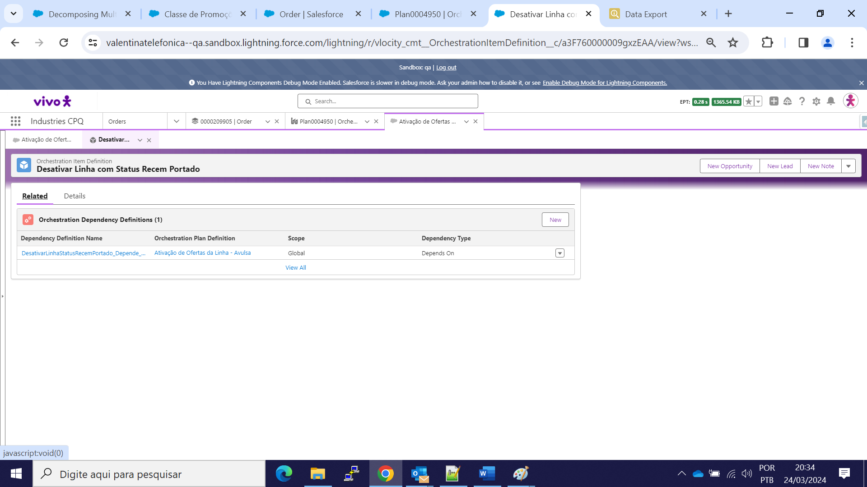

Cadas orchestration plan definition na sua criação tbm é definido a sequencialidade, ordem das execuções, quanto menor o numero 1° sera executado



Com a decomposição realizada e a orquestração iniciada, cada orchestration plan definition invoca os seus callouts(orchestration item) baseado no orchestration scenario que foi mapeado como regra. Dentro do callout temos uma IP que é executada, essa IP sempre chama um DataRaptor para recuperar o id do FulfilmentRequestLine contendo todos os atributos que foram salvos no envio do carrinho(item decomposição la acima)....depois de recuperar o id, essa IP baseado no orchestration_item_id, é chamada a classe FulfilmentRequestLineController enviando os atributos dos produtos técnicos que desejo recuperar os valores + o id do FulfilmentRequesLine no RemoteAction que esta dentro da IP. Esses objetos de fulfilment provavelmente são gravados com base informação da decomposição.

Exemplo abaixo de uma IP chamado no callout de um plano de orquestração

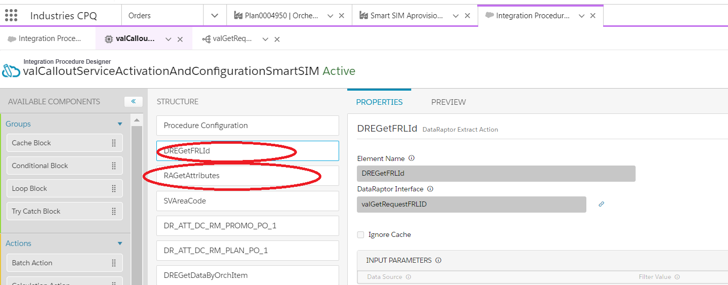

ID do FulfilmentRequestLine retornado a partir do orchetrationitemid (callout) da ordem(preciso entender essas amarração).

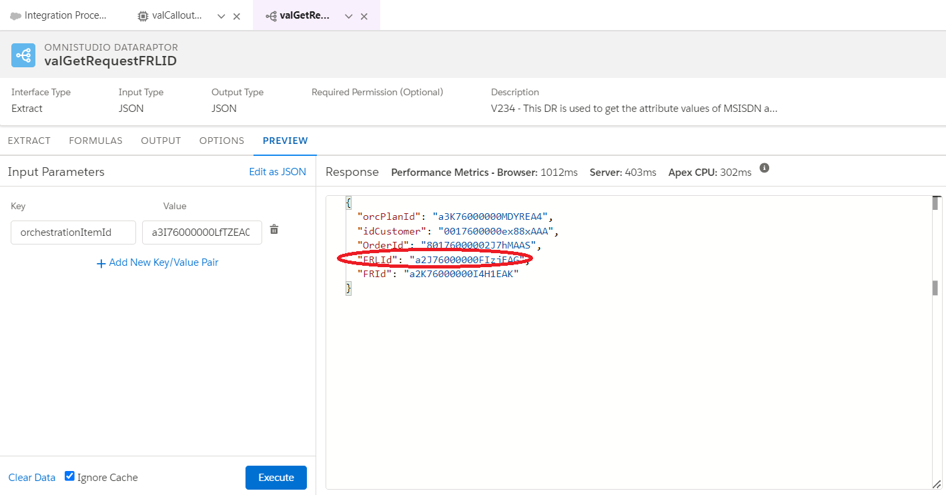

Se executarmos essa query com o id retornado na figura anterior do data raptor, vai ser retornado na base a lista dos atributos

**select Id, vlocity_cmt__Action__c, Name ,vlocity_cmt__FulfilmentRequestID__c, vlocity_cmt__FulfilmentStatus__c, vlocity_cmt__InventoryItemId__c,**

**vlocity_cmt__Product2Id__c, vlocity_cmt__AttributeSelectedValues__c**

**from vlocity_cmt__FulfilmentRequestLine__c where id = 'a2J76000000FIzjEAG'**

Classe Apex que é invocada para recuperar os valores dos atributos que posteriormente é repassado no payload request para o sistema de destino

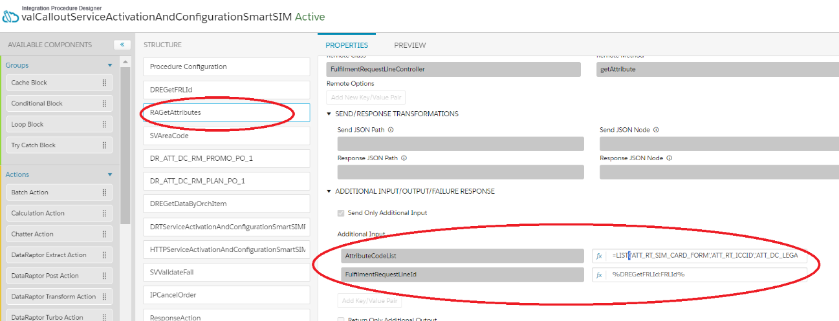

E assim compomos um request para um sistema externo.

**Those are Offers, Products, Services, and Resources.**

**Offer:** is an aggregation or bundling of Products for sale to a Customer

**Product:** is what an entity (supplier) offers or provides to another entity (customer).

A product may include service, processed material, software or hardware or any combination thereof.

A product may be tangible (e.g., goods) or intangible (e.g., concepts) or a combination of them, However,

a product ALWAYS includes a service component.

**Service:** are developed by a service provider for sale within Products.

The same service may be included in multiple products,

packaged differently, with different pricing, etc.

Under TM Forum Frameworks there are two types of Services:

**Customer Facing Services**

**Resource Facing Services**

**Resource:** represent physical and non-physical components used to construct Services. They are drawn from the Application,

Computing and Network domains. They include, for example, Network Elements, software, IT systems, and technology components.

Resources may be virtualized, as well as abstract.

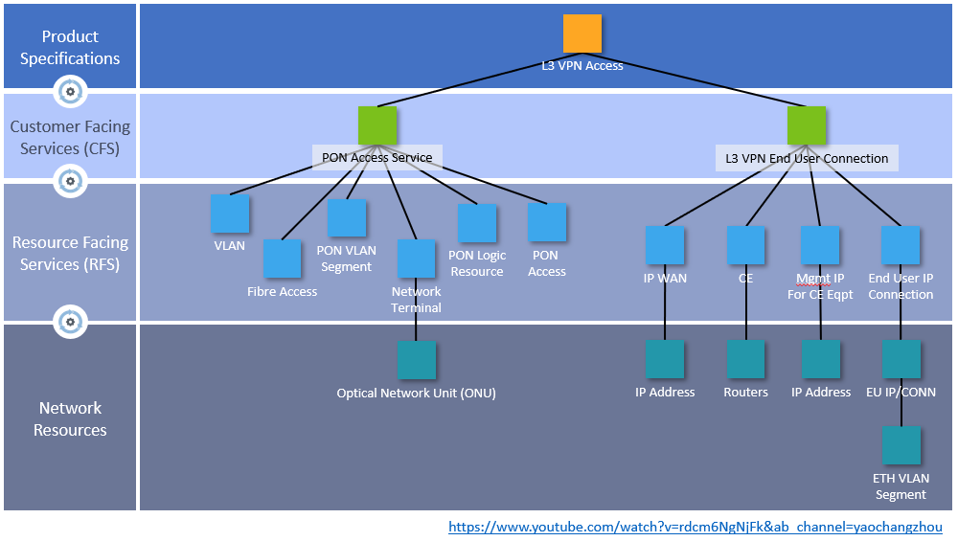

https://passionateaboutoss.com/differences-between-cfs-and-rfs/

Vivo

Plano -> Product Specification?

Promoção -> CFS?

RFS -> Servicoes de rede abaixo das promoções? E Se fosse abaixo do plano teria um CFS do tipo Sim Card?

Network Resources -> Sistemas externos.

Montar um passo a passo para criar um produto, plano de orquestração, decomposição e etc.

Entender certinho o catalogo do pre e fazer um teste de ativação/desativação de promoção e pacote e entender como se comporta. Decompoes sempre td? Provavelmente a modelagem de plano abaixo da promoção prejudicou os workflows.

**Orchestration Plan Rollback**

Rollback do Salesforce no fluxo de Hab Remota

O primeiro callout é o "Smart Sim Ativações de Itens de Rollback" que é um milestone e tem uma atividade de rollback associada referente que

se chama: Executar Rollback no HRS. Precisa entender o porquê milestone gera callout mas por hora segue o jogo.Aqui ha uma

atividade/callout de rollback associado para o HRS.

A segunda atividade é o "Smart SIM Aprovisionamento", que é um callout e quando da erro na chamada para o Smart Sim na integration

procedure, é chamada uma outra integration procedure que é a IPCancelOrder/valCancelOrder, que chama a classe vlocity_cmt.CPQAppHandler

com o método createSupplementalOrder e a ação Cancel. Isso gerara uma ordem suplementar dando rollback em todas as atividades

anteriores que tem um plano de Rollback Plan Definition associado ao orchestration item. No caso chamararia o HRS, que é a atividade associada

ao 1° callout acima. Qualquer coisa abrir o orchestration plan definition dessa atividade de rollback e verificar todos os callouts

A terceira atividade é o "call back Smart Sim Aprovisionamento", caso aconteça algum erro ele tentara desafazer a chamada com sucesso para o "Smart

Sim Aprovisionamento"(fluxo anterior). Toda vez que a classe vlocity_cmt.CPQAppHandler

com o método createSupplementalOrder e a ação Cancel que esta dentro a ip dessa atividade é invocada, e a atividade anterior tiver sido

concluida com sucesso, o rollback sera triggado e o desfazimento executado.

**Configurando produto com variação de preço por alguma regra(ex: DDD)**

No Vlocity Product Designer selecione o produto e o campo ou o filtro que possívelmente tem uma rule/regra associada. Esta dessa forma: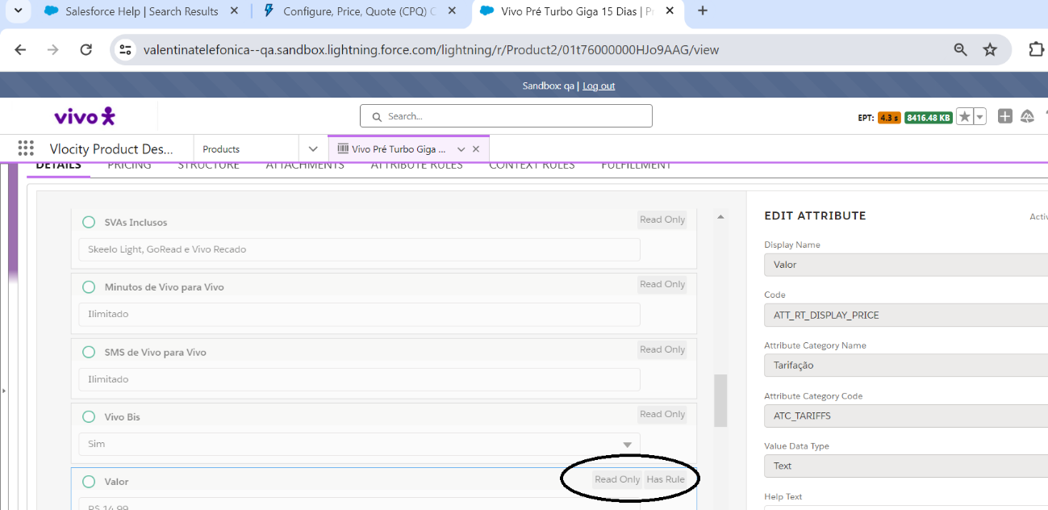

No Vlocity Rules eu procuro a regra que esta associada ao atributo. As vezes tem que fuçar pq não estara explicito

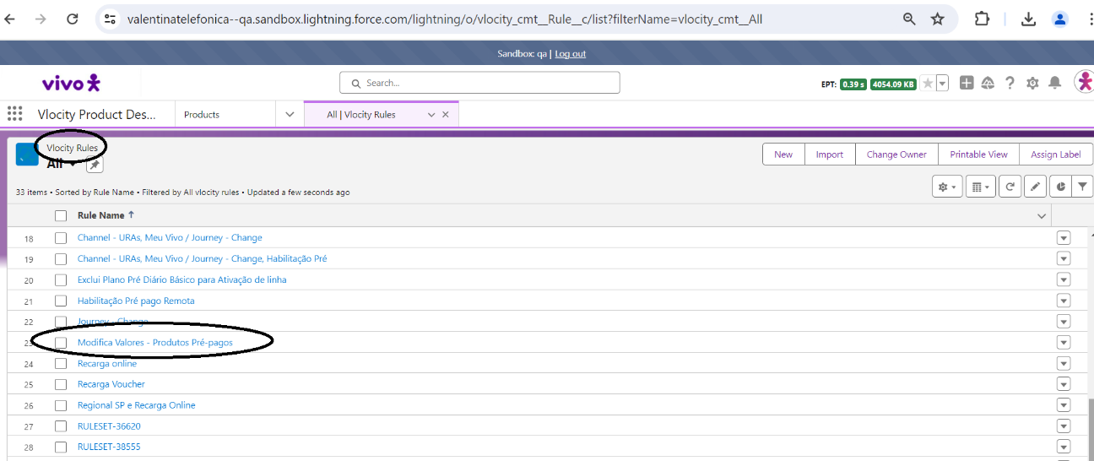

Uma vez que voce seleciona a regra e clica em editar, voce conseguira ver o product relationship, a regra e o atributo que esta sendo considerado

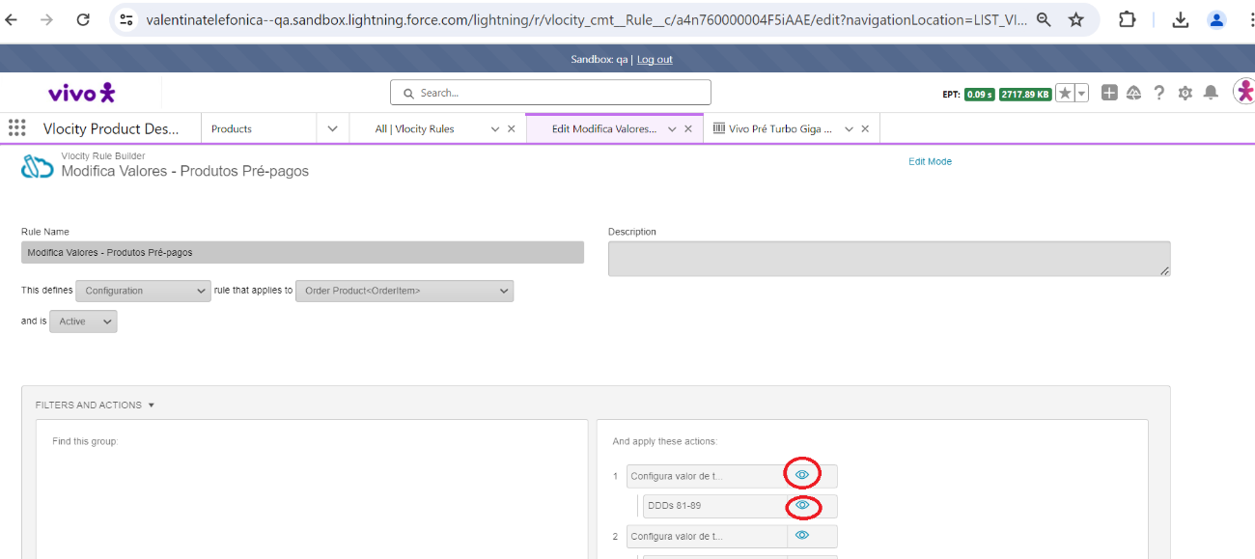

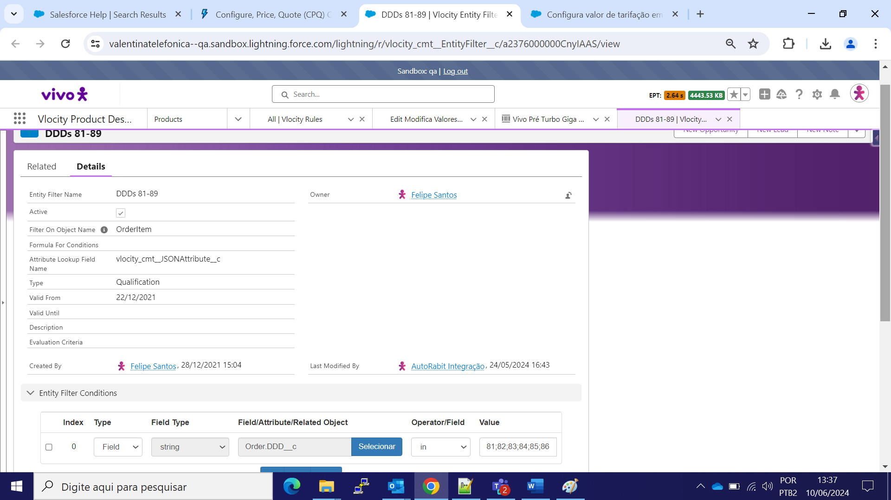

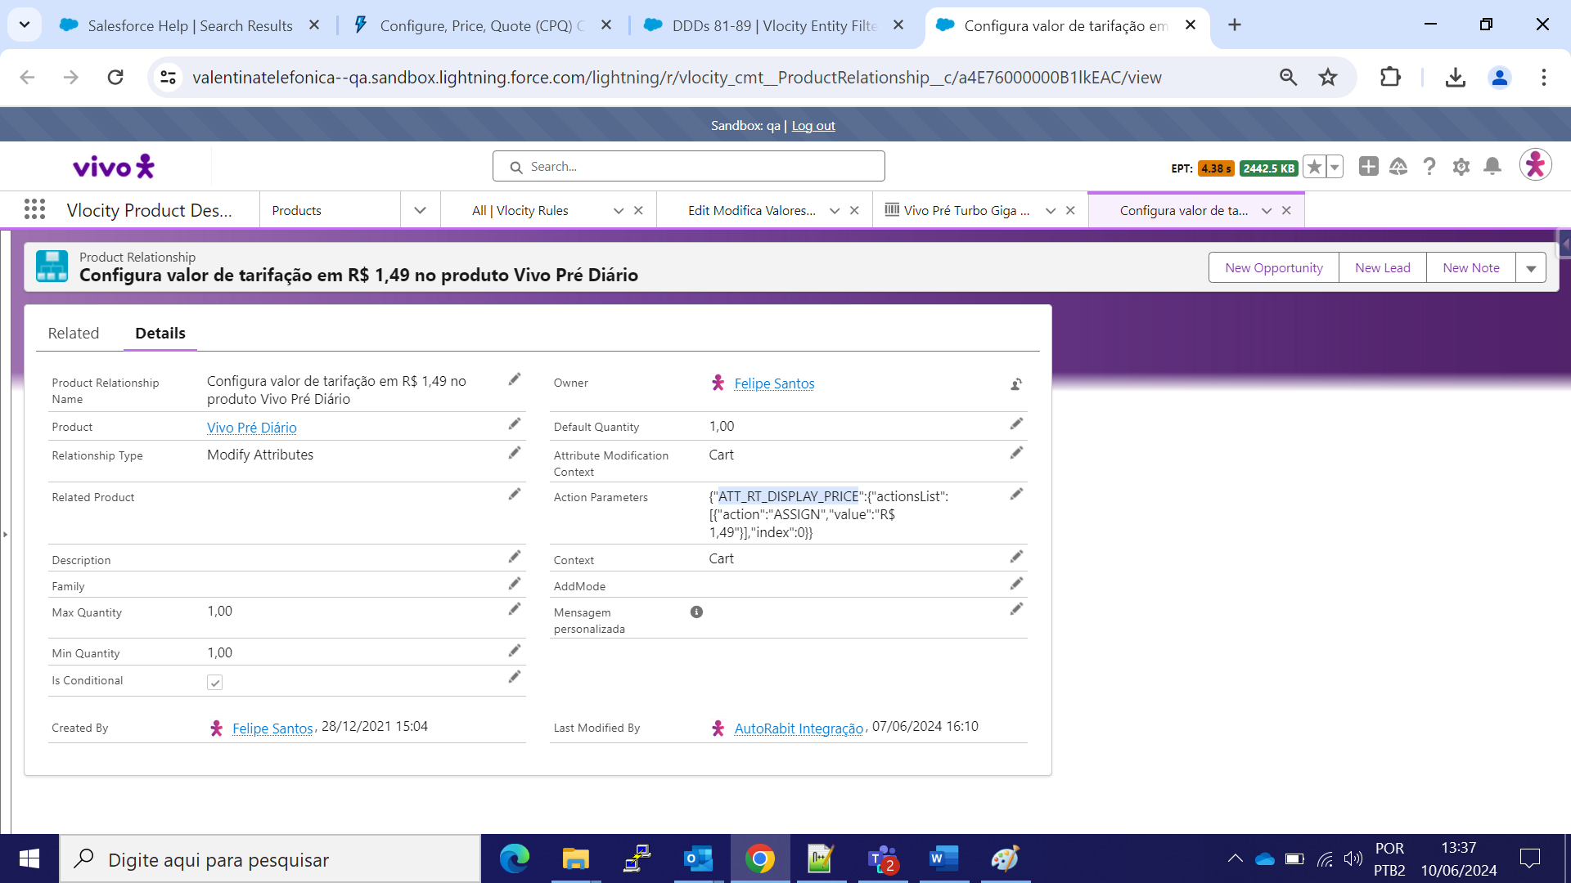

**Essa é a regra que define qual o produto default de um bundle, caso eu não deseje configurar/selecionar isso em TELA**

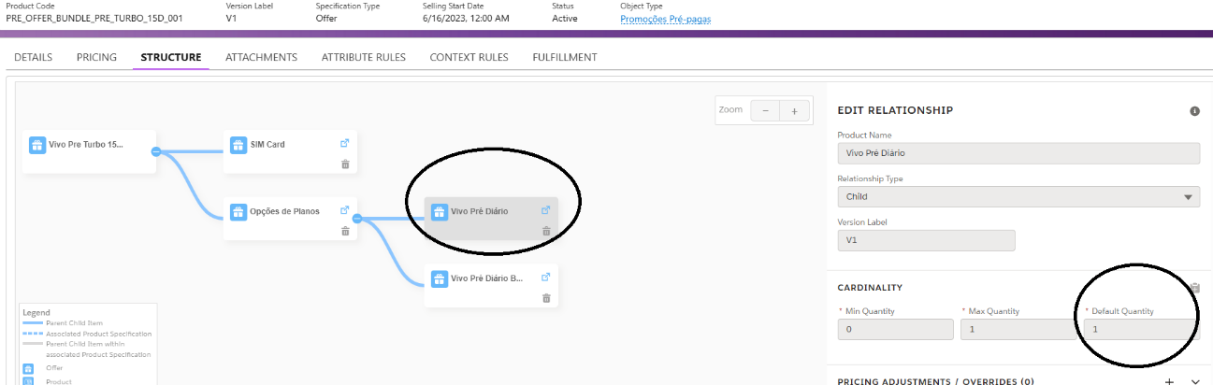

-----------------

**Criação de novos mapeamentos (campos e objetos) para filtros de Context Rules**

Os componentes abaixo são equivalentes entre os diferentes APPs. O ideal ainda e usar o Vlocity Product Console que é mais funcional.

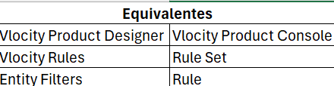

1. Preciso mapear o objeto(Context Scope) corretamente no CPQ, para poder criar regras através do objeto/campo mapeado

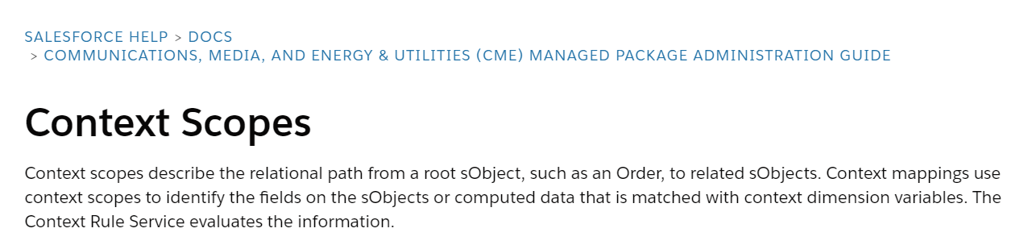

No exemplos abaixo tenho os 2 objetos mapeados para possível criação de regras no CPQ

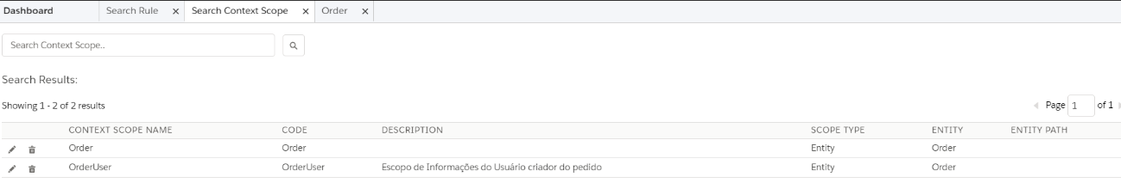

Dentro do objeto Order por exemplo consigo visualizar todos os campos que estao mapeados e disponiveis para fazer regra/match no vlocity Rules

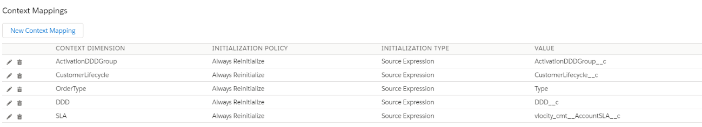

* + 1. Após o mapeamento do objeto, no Context Dimension mapeamos o campo.

Abaixo todos os campos que já estao criados e disponibilizados para mapear informação, a partir do passo anterior(context scope)

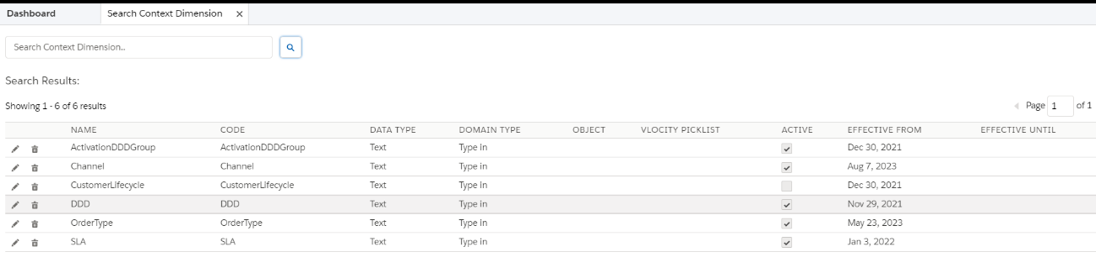

* + 1. Com isso agora podemos criar as “Rules”, que são regras singulares em cima do Scope e Dimension criados anteriormente

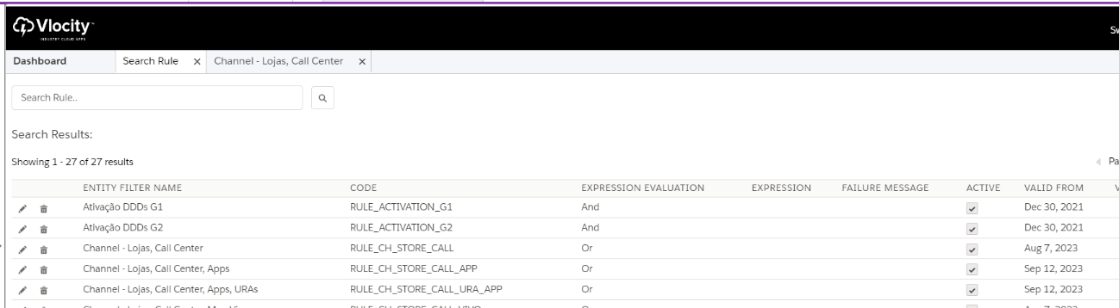

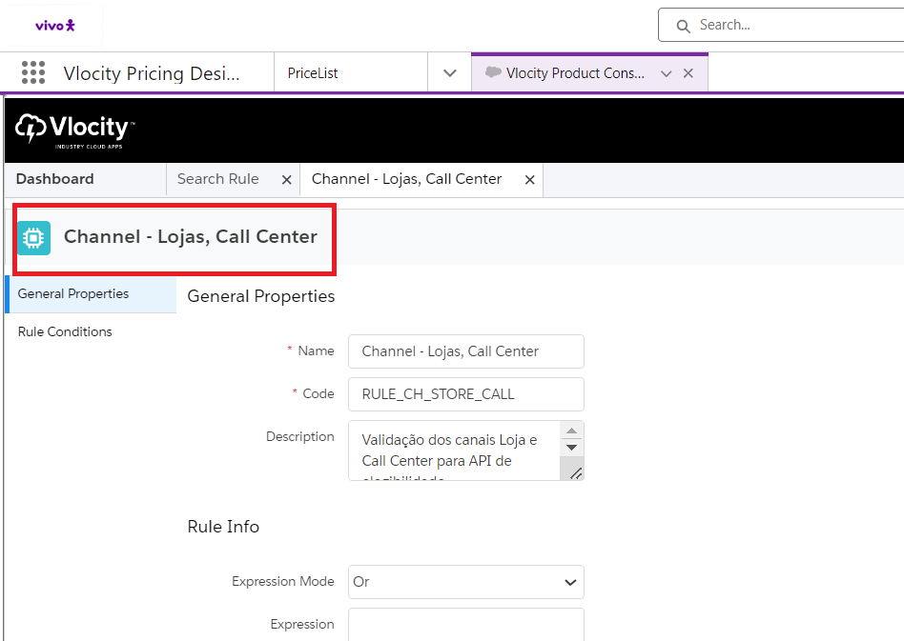

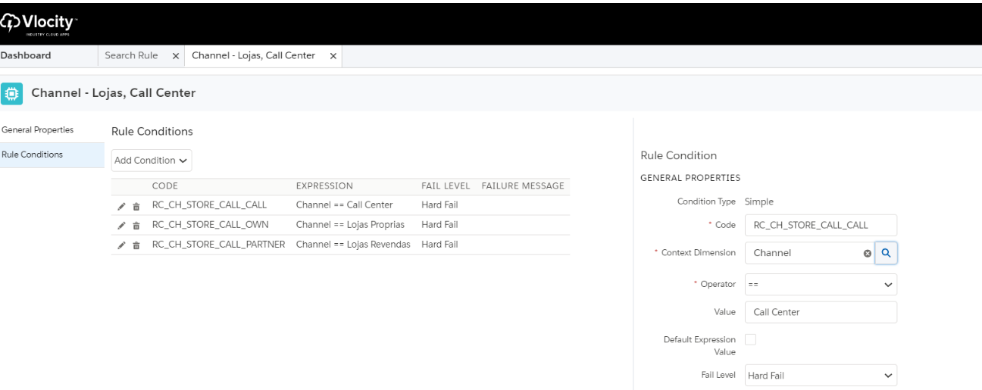

* + 1. Depois no Rule Set posso criar regras compostas entre diferentes ContextDimension(campos) para compor minha regra principal

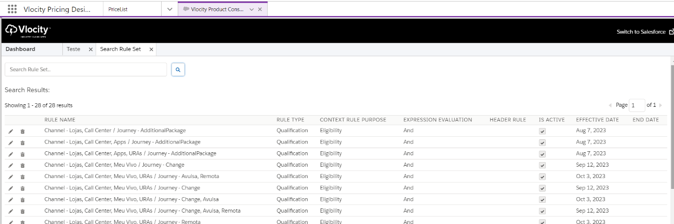

Por ultimo no Vlocity Product Designer faço as associações dos Context Rules ao produtos

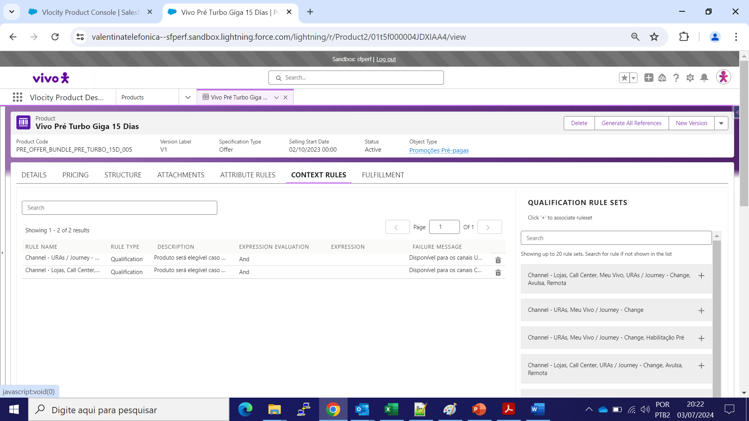

**Configurar uma promoção no catalogo**

1. Realizar a configuração através do Vlocity Product Designer, setando o produto como orderable.
2. Realizar a configuração do Context Rules corretamente para aparecer no fluxo principal.
3. Realizar a configuração no objeto Product Eligibility.
4. Para novas promoções configurar no registro de metadado com o correto DDD.
5. Realizar a configuração no objeto Catalogo, associando o produto ao Catalogo.
6. Realizar o refresh dos jobs.
   1. Job de limpeza de hierarquia.
   2. Job de limpeza de cache.
   3. Job de carga de cache.
   4. Job de atualização de cache selecionando o catalogo correto.

UM PONTO IMPORTANTE É QUE É NECESSARIO CONFIGURAR PARA AS NOVAS PROMOÇÕES(VIVO TURBO) AS REGRAS DE CONVIVENCIA ENTRE ORIGEM E DESTINO. ISSO SE DEVE AO FATO DO COMPONENTE DE GESTAO DE PROMOÇÃO UTILIZAR AS O MÉTODO getCartsTargetOffers do CPQHANDLER, que faz uma validação se as promoções de origem e destino estão configuradas no VLOCITY PRODUCT DESIGNER

https://developer.salesforce.com/docs/industries/cme/references/cpq?meta=Get%2BTarget%2BOffers

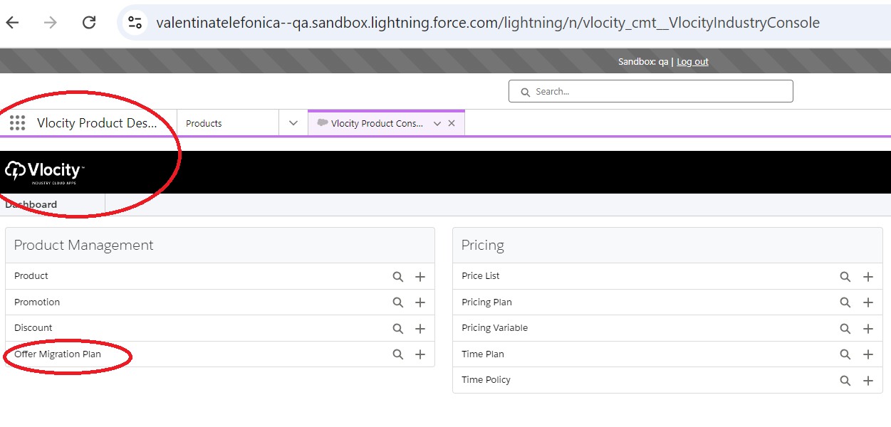

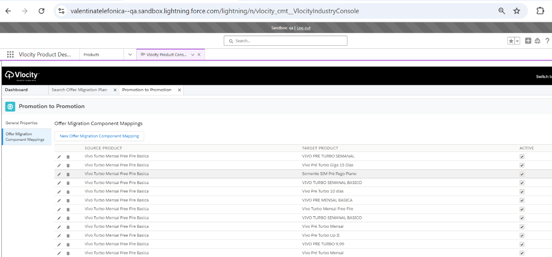

Um ponto importante, quando se usa esse método na troca de plano, o processo de decomposição transfere todos os valores dos atributos do produto antigo, para o produto novo(desde que seja o mesmo atributo, nome de atributo). Essa é uma característica padrão. Para evitar que o atributo seja sobrescrito com o valor do produto de origem, é necessário selecionar o produto, ir no atributo e configura-lo como read-only(dentro do produto). Logo não haverá sobreescrita de valores

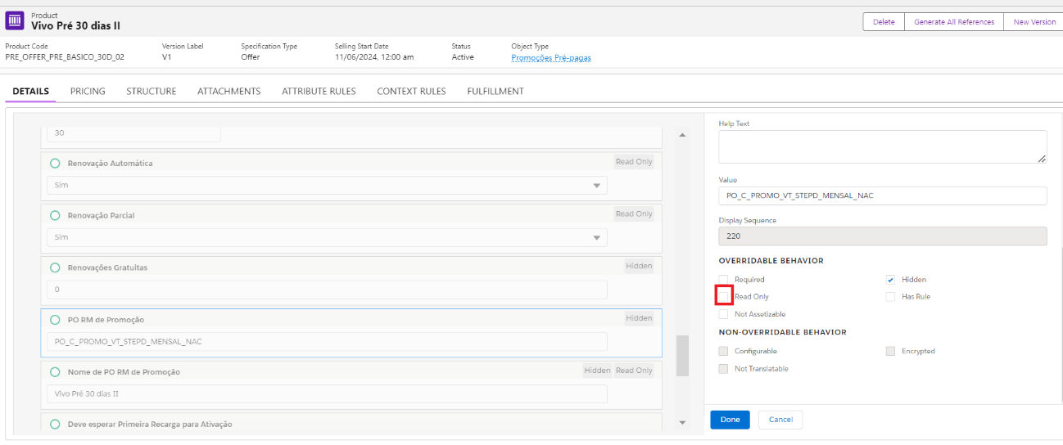

Quando tivermos novos canais de atentimento, precisa configurar o campo Channel do objeto Order

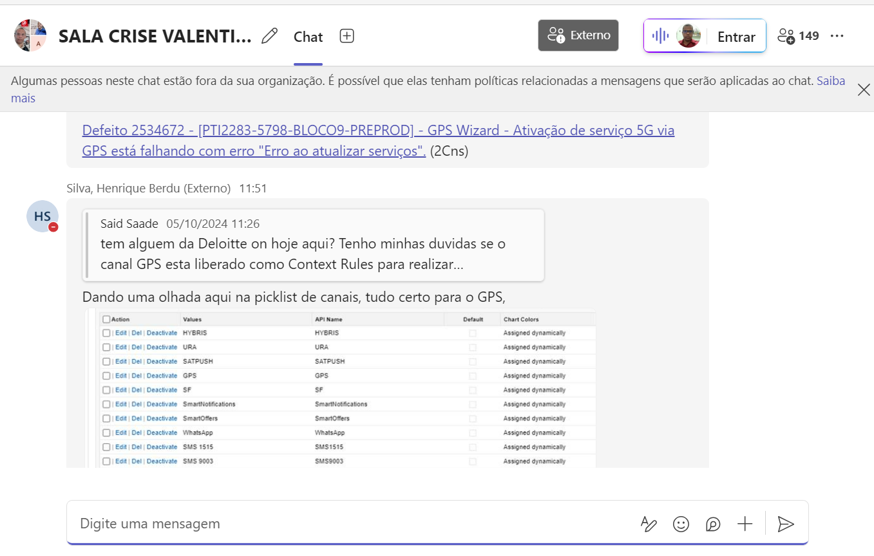

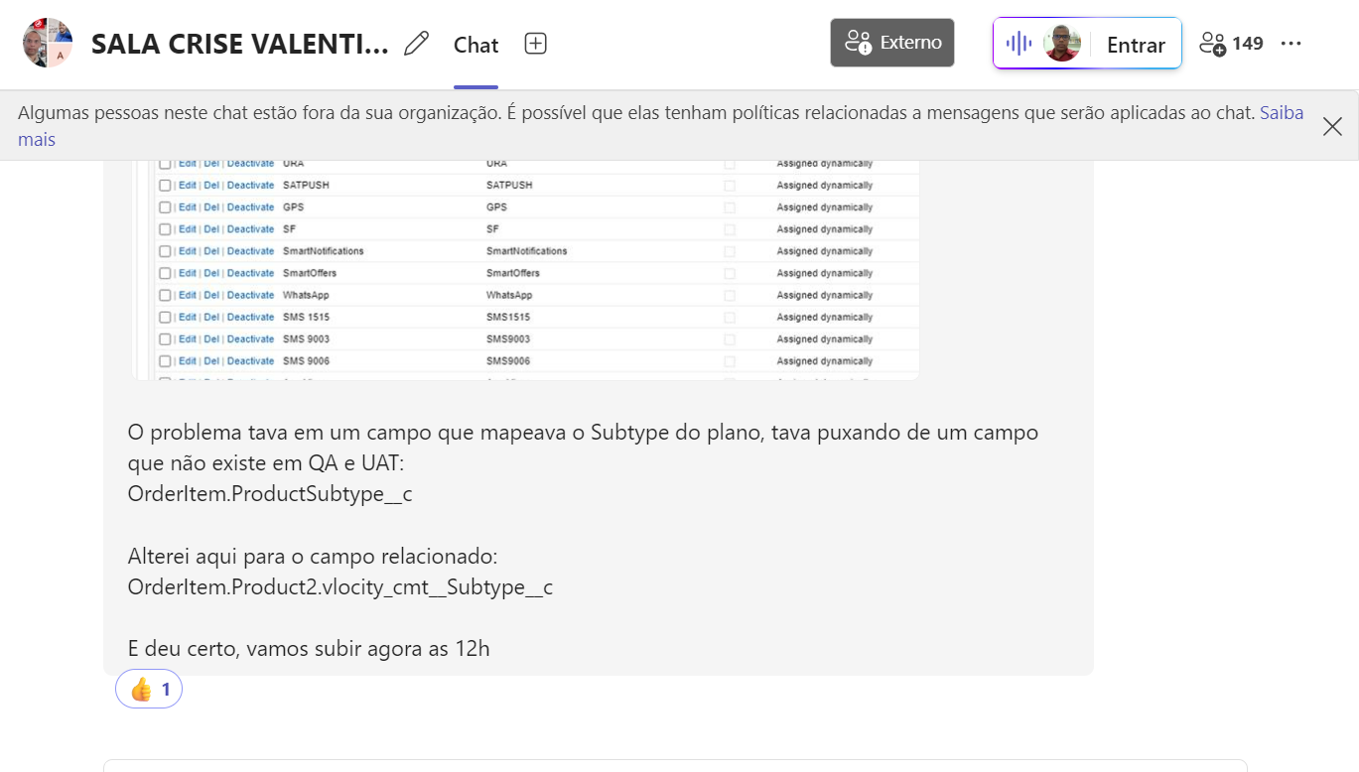

Correlation between the push event and the callout.

How do I know when an orchestration plan should be resumed once a condition is matched in a push event? How does the push event know is about this specific orchestration item/fulfilment request line?

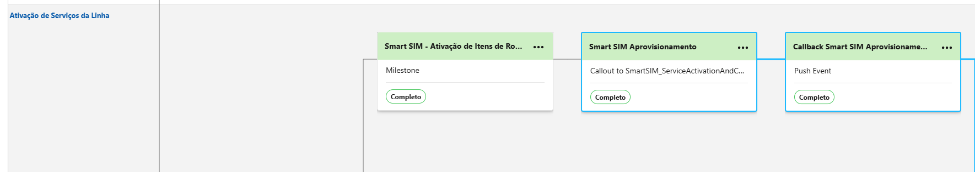

1. Once the external system sends the call back to Salesforce, an integration procedure which is not associated directly in the orchestration item changes the atributte value for a specific orchestration item, which triggers the conditional created in the push event orchestration item

ValCallBackProvisioning(integrarion procedure it’s not associated to any orchestration item) -> It’s invoked by the external system and the attribute is changed for a fulfilment request line that is sent from the external system.

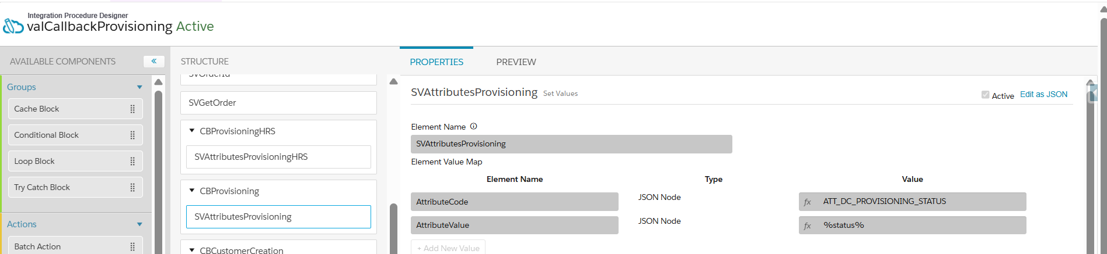

Callback Smart Sim Aprovisionamento -> Conditional is triggered and the orchestration plan is resumed.

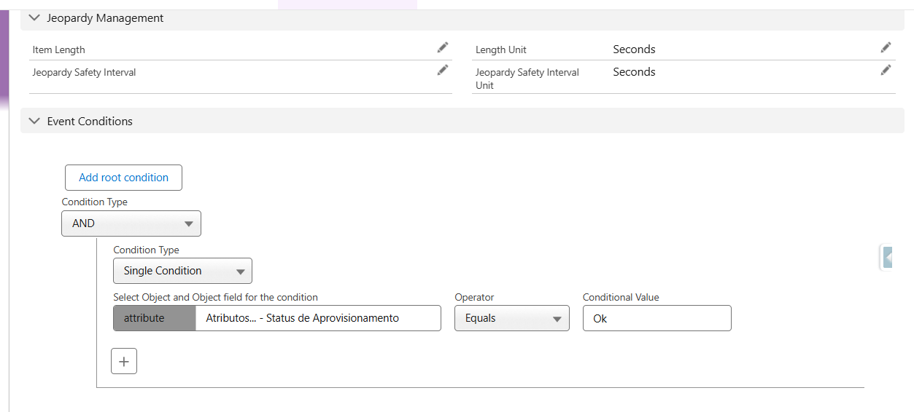

How do I know it’s triggered for that specific line item? Once the condition is only an attribute. Since the push event is associated to a technical product which is associated to that fulfiment request line(FRL), any changes to the associated FRL will trigger the push event. Don’t forget all orchestration items contained in the orchestration plan will be associated to the same technical service, consequently the same frl

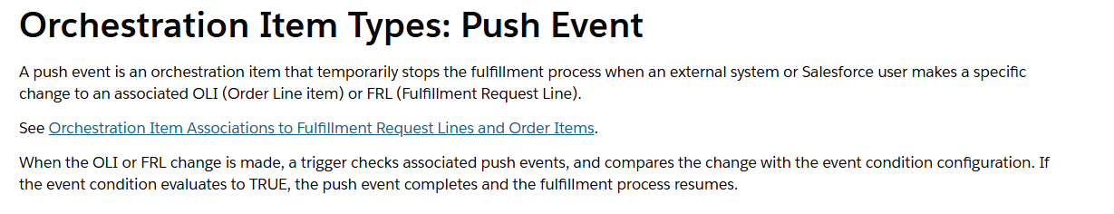

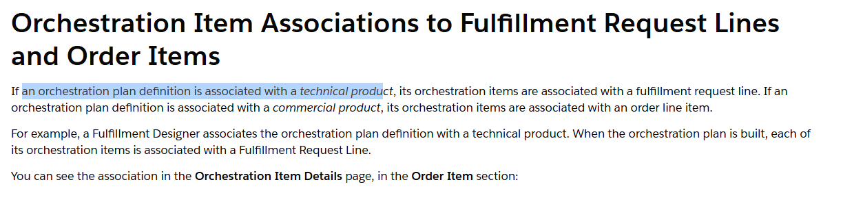

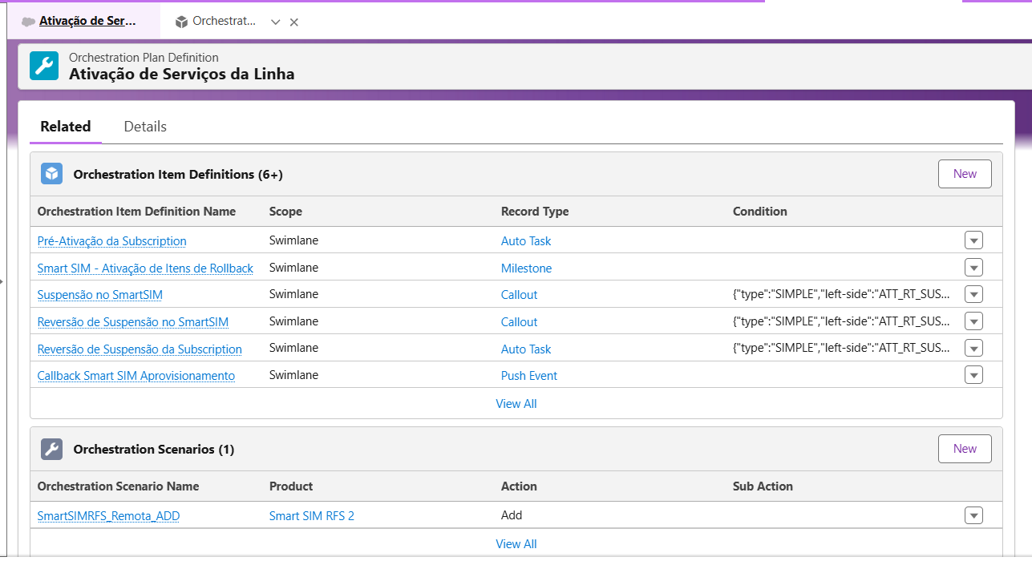

The Callback Smart Sim and Smart Sim Aprovisionamento is associated with the s technical product and same frl, inheriting the same attribute value. Once it’s updated through the call back request, the attribute is updated to the call back line item as well and the trigger is started.

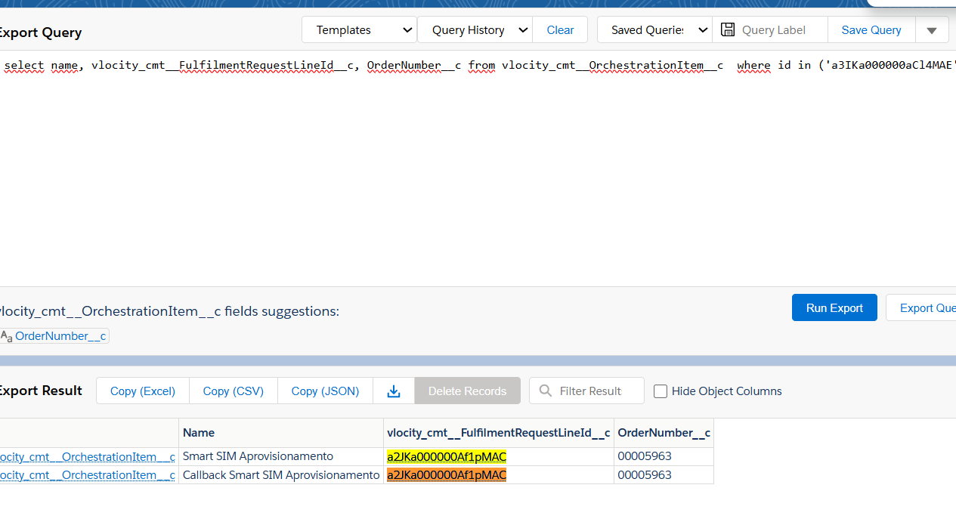

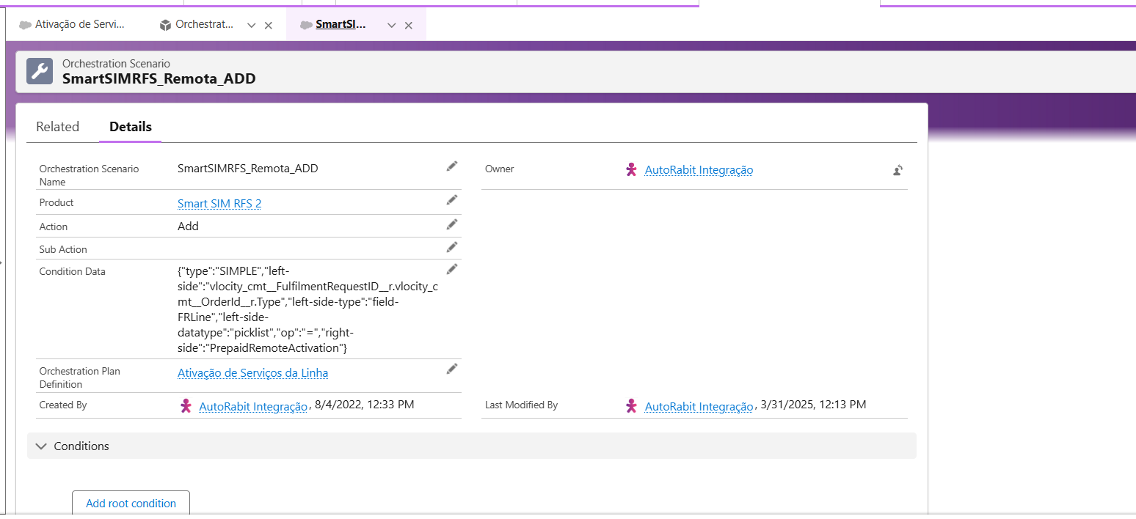

Below the updated attribute for the both fulfilment request line(Smart Sim and Call Back)

